Manager, Governance

City of Kingston – Kingston City Council

PO Box 1000

Mentone 3194

[governance@kingston.vic.gov.au](mailto:governance@kingston.vic.gov.au)

Dear Sir/Madam,

**Re: Community Local Law Amendment 2021**

Thank you for the opportunity to make a submission.

**9. FIRE: - Backyard Fire Pits**

You cannot have a wood fire pit without wood smoke.

Sadly the image below is misleading.

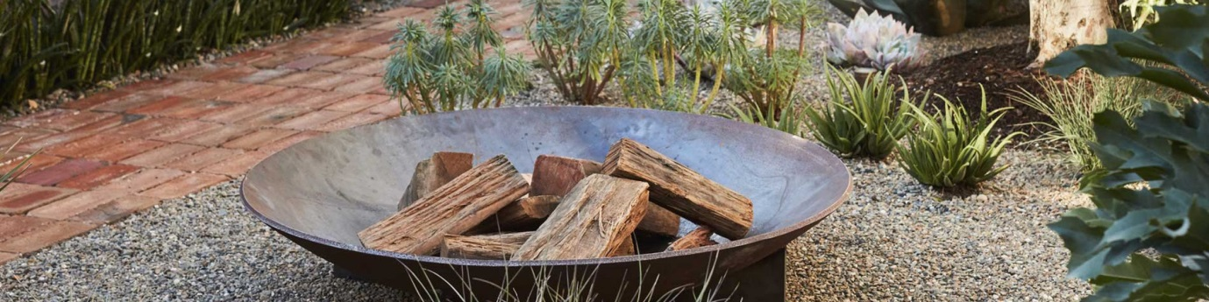

On the City of Kingston [webpage](https://www.yourkingstonyoursay.com.au/local-law-amendment-2021?fbclid=IwAR05JqpKoTq_ja0J7MLFhTXzU3bVE1kQuw7oogvrlFkWemvl7XkrEEb_Z6o) announcing changes to Community Local Law it is stated…

*“Local Laws help protect public health, safety and amenity throughout Kingston.”* and there is a photo of a fire pit. Having fire pits will do nothing to protect public health or amenity in Kingston.

**Purpose of the Local law. I**t is claimed to:

* *make improvements to provide for a safe and healthy environment so that the community can enjoy a quality of life that meets its expectations*
* *provide for improvements for the protection and enhancement of the amenity and environment of the municipality;*

Again, it cannot be shown fire pits provide for a safe and healthy environment, or for the protection and enhancement of the amenity and environment of the municipality; quite the opposite in fact.

The World Health Organisation’s peer reviewed health studies show wood smoke (particulate matter or PM2.5) from, for example a fire pit as pictured, is a Group 1 carcinogen along with other Group 1 carcinogens such as asbestos, arsenic, formaldehyde and mustard gas to name a few. The WHO also says there is no safe level of particulate pollution.

Cleanairtas believes people in the Kingston City Council municipality should be having their needs and expectations met with clean air as a number one priority above anything else.

It could not be found where wood smoke, and the harm it causes, has been defined by Kingston City Council.

Tobacco smoking regulations have been clearly defined by the council and yet most of the harmful substances found in tobacco smoke are the same as found in wood smoke.

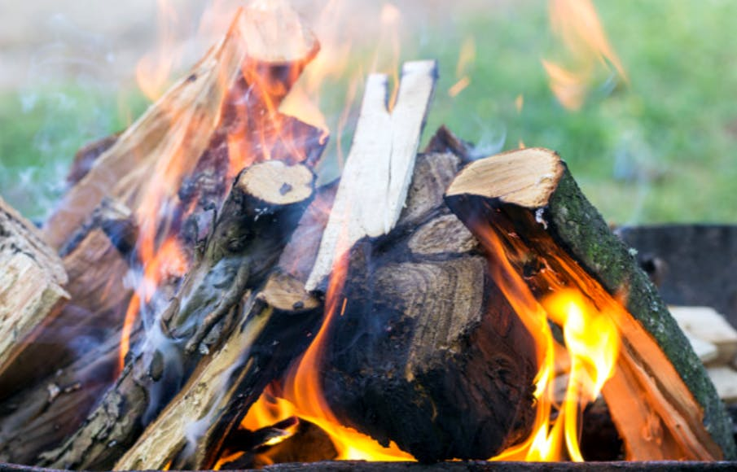

[Backyard Fire Pits have your say](https://www.yourkingstonyoursay.com.au/backyard-fire-pits) – Kingston City Council website

**Clause 210** 'A person must not light or allow to be lit or remain alight a fire in any incinerator or other structure used for the purpose of burning solid fuel materials to create heat outdoors.'

*“This was included in the Community Local Law to prevent smoke-related health problems. Electric and gas heating options are also considered to be more environmentally friendly.”*

**Clause 208 in the current Community Local Law provisions must be maintained where it states:**

**“A person must not light or allow to be lit or remain alight a fire in the open air that causes a nuisance by odour, smell, smoke or any other means.”**

Cleanairtas strongly AGREES with this, it should not change and it should apply to fire pits.

In relation to health problems the following should be noted:

***‘Every single disease that is non-communicable is impacted by air pollution. It is not only involved in worsening diseases but in causing them, and new diseases, that wouldn’t otherwise occur are happening because of air pollution.’* –** [**Sir Stephen Holgate**](https://www.southampton.ac.uk/medicine/about/staff/sth.page)**, Professor of Immunopharmacology and a respiratory physician**

[Referring to the draft Community Local Law 2021](https://www.yourkingstonyoursay.com.au/74198/widgets/359190/documents/221075)**:**



**204**. Agree

**205.1 and 205.2**. **Fuel reduction**. DISAGREE. There are other safer methods to achieve fuel reduction than burning.

In his journals in 1770 Captain James Cook described the land (Eastern Australia) as “a continent of smoke” and noted that “we saw smoke by day or fires by night wherever we came.”

We don’t want to go back to this do we?

The science today is abundantly clear, all smoke is harmful. This is why we have cigarette smoking, backyard burning, and wood heater regulations to name a few. . Our health system is hardly coping and now researchers have found a link between PM2.5 and COVID.

Smoke has no boundaries. It will not just stop at the fire pit.

UTAS Fire Science Prof David Bowman should not be advocating our indigenous people undertake outdated cool burning practices. Cool burns create pernicious smoke because of incomplete combustion. We should not be using the air as a sewer.

We don’t want susceptible people i.e., the young, the elderly those with lung or heart disease breathing more smoke. Put all fires out and put them out fast at the source, extinguish the smoke, don’t create it.

UTAS Fire Science Prof David Bowman is on record as saying "...who cares whether we achieve fuel management with burning, fuel management can be achieved with brush cutters, fuel management can be achieved with goats."

Why aren’t we? Serial pyromania is the desire to keep burning things.

**206.** AGREE

**Fire on Private Property:**

**207.** ‘Clause 204 does not apply to a fire lit on private property.’ DISAGREE, this is inconsistent. **204** states, ‘***must not***’ light a fire ‘***on any land***’.

However **207.** in the current Community Local Law says, ‘Council may issue a permit for the purpose of cooking for cultural activities or for the purpose of enabling religious observance.’ This cannot be disregarded and the word ‘may’ has to be changed to ‘must’. There can be no excuses or exemptions for causing smoke harm. See for example **205.1 & 205.2.** above for indigenous cool-burning practices.

**Fire Hazards:**

**208.** AGREE

**Roads and footpaths:**

**209.** AGREE

**Incinerators:**

**210.** AGREE

**211.** AGREE

**212.** AGREE

**Electric and gas BBQs, pizza ovens, and manufactured fireplaces:**

**213.** AGREE

**Directive Powers:**

**214.** AGREE

**215.** AGREE

**216.** AGREE

**217.** AGREE

**(7)** **Schedule 1**: AGREE

**(8)** **Table in Schedule 1**: DISAGREE, see below…

Increased penalty units. AGREE

However, if these 7 penalty units replace and renumber the existing 10 it is NOT AGREE for the flowing reasons…

**204.** AGREE

**206.** - currently **205.** AGREED

**208.** Fire hazard – changed from ‘Allowing fire to cause a nuisance’. DISAGREE.

Quite wrongly, smoke from fires is commonly called a ‘nuisance’ when in fact it can be deadly.

**209**. – currently **212.** AGREE

**210.** AGREE

**211.** AGREE

**215.** currently **220.** AGREE

**205.** Leaving a burning fire unattended appears to have been removed. DISAGREE

**216.** Location of barbeques (fire pits?) seems to have been removed.

**217.** Seems to have been removed in relation to nuisance of barbeque, odour and smoke. Fire Pits? DISAGREE.

Clause **208** in the current Community Local Law provisions must be maintained, see above.

**218.** Seems to have been removed in relation to allowing a barbeque (fire pit?) to remain alight for a purpose other than cooking food.

AS/NZS standards have been made in relation to wood heater efficiency and emissions, i.e. 1.5ug/kg wood burnt. Both a wood heater and a fire pit vent to the outdoor environment and yet fire pits have no emission control.

Then we have the Kingston City Council’s current Community Local Law on:

**Chimneys**:

**23.** *‘The owner or occupier of any premises must not cause or allow any chimney on*

*that land to discharge dust, grit, ash or smoke to such an extent that it is*

*dangerous to health or is offensive to another person.’*

Smoke is smoke it is just as toxic from one source as another; even more so from a fire pit without any emission limiting features.

Smoke from neighbours is already a health problem. It is costly in terms of lives lost and people not being able to reach their full potential. It puts people against people. It is a huge burden on our health system. Now incinerators are banned people are burning toxic waste in fire pits. Why create more carcinogenic smoke by allowing solid fuel fire pits?

***"There has got to be an understanding that people who complain about smoke***

***have a legitimate case, the medical science is on their side now."*** - Professor David Bowman, Tasmania. ABC News Feb. 20, 2012.

No solid fuel fire pits.

<https://cleanairtas.com>

6th February 2022

----------------------------------------------------------------------------------------------------------------

Not for publication

Contact person Clive Stott

[cleanair@cleanairtas.com](mailto:cleanair@cleanairtas.com)