Donald Trump wants California to rake forests to prevent fires. Here's the backstory

First published here: https://www.abc.net.au/news/2018-11-19/why-donald-trump-says-raking-forests-would-stop-california-fires/10509984

By Liam Butterworth
Updated 20 Nov 2018, 2:07pmTue 20 Nov 2018, 2:07pm
Sorry, this video has expired
Video: Trump urges California to rake its forests, like Finland (Photo: AP) (ABC News)
Related Story: Trump says California fire hasn't changed his opinion on climate change
Related Story: In the ruins of California's Paradise, there's a very Australian story
As California comes to terms with the deadliest wildfires in its history, United States President Donald Trump has offered a solution to the problem.

Key points:
- Donald Trump said Finland doesn't have fires like California because they rake and clean their forests
- Finnish President rejects Trump's claim that they spoke about raking
- About 70 per cent of Finland is covered in forest
Mr Trump said California authorities should copy Finland's example and rake forest floors to remove the material which fuels fires.
Except Finland does not have that strategy for managing its vast forest reserves.

Here's what Mr Trump had to say about Finland and its forests
Mr Trump suggested he got the raking idea after speaking with Finnish President Sauli Niinisto in Paris for the Armistice Day centenary commemoration.
"You look at other countries where they do it differently, and it's a whole different story," he said.
"I was with the President of Finland, and he said: 'We're a forest nation' and they spent a lot of time on raking and cleaning and doing things, and they don't have any problem."
Mr Trump made the comments while visiting the west coast state and while chatting to survivors of the Camp Fire blaze, which has killed 77 and destroyed more than 12,000 properties.
Volunteers across the state are sifting through the burned wreckage of houses looking for remains and Mr Trump suggested raking as a form of management to stop fires of that scale happening again.
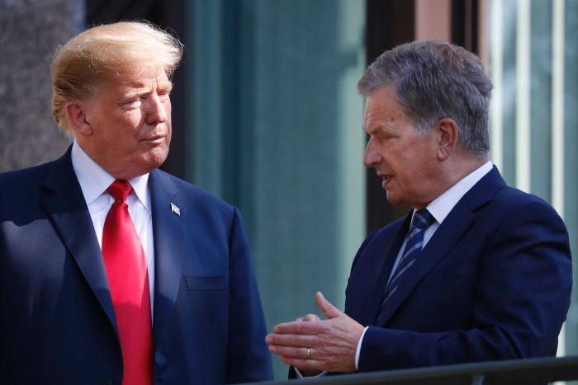Photo: US President Donald Trump spoke with Finnish President Sauli Niinisto about fire management in Paris. (AP: Pablo Martinez Monsivais)

But Finland's President said he never mentioned raking
He isn't sure where Mr Trump got the idea that raking is part of his country's routine for managing its substantial forests.

Paradise burning
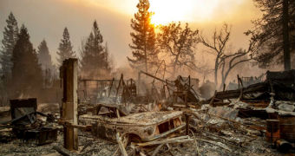
In the secluded town of Paradise, James Bennett finds carnage and destruction reminiscent of Victoria's Black Saturday fires — and a community with the same grit to start over.
Mr Niinisto told Finnish newspaper Ilta-Sanomat raking had not come up when they talked in Paris.
"I mentioned [to] him that Finland is a land covered by forests and we also have a good monitoring system and network," he said.
Mr Niinisto said their conversation focused on the California wildfires and the surveillance system Finland uses to monitor forests for fires.
He remembered telling Mr Trump "we take care of our forests," but couldn't recall raking coming up.
Forests cover more than 70 per cent of Finland's 338,000 square kilometres.
The Nordic country with a population of 5.5 million is home to some of the world's biggest paper and pulp companies.
Forest fires are still a problem in Finland but the country has an early-detection network, aerial surveillance and a widespread forest road network, which helps bring fires under control quickly.
The two regions also have very different climates and environments, with California's dry, hot conditions more susceptible to blazes.
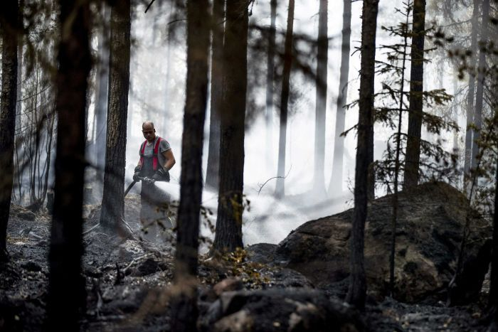Photo: Forest fires are an issue in Finland, but the country has early-detection schemes in place to reduce the severity. (Reuters: Roni Lehti/Lehtikuva)

If not from Finland, where did Mr Trump get the idea from?
Mr Trump first seemed to raise the idea of raking a few days before he made the comments to the California officials in a burnt-out caravan park in the fire-ravaged city of Paradise.
Before he flew to California, Mr Trump mentioned it in an interview with Fox News at the White House.
The US President reportedly watches hours of cable television each day, especially Fox News, and has been known to tweet about topics he just saw on TV.
"I was watching the firemen the other day and they were raking areas," Mr Trump said.
"The fire was right over there and they were raking trees, little trees like this, nut trees, little bushes that you could see were totally dry, weeds.
"And they're raking them and they were on fire and that should have been all raked out and you wouldn't have had the fires."
Sorry, this video has expired
Video: Drone footage of areas devastated during California's deadliest wildfires (ABC News)

Raking might not be practical, but Mr Trump has a point about forest management
Ever since the seriousness of the California blaze first became clear, Mr Trump has spoken repeatedly about forest management and fires.
In his first comments about the California disaster on Twitter, rather than offering condolences, the President threatened to withdraw federal payments and blamed the state's "gross mismanagement" for the fires.
This is despite the US Government being responsible for 57 per cent of the state's forests.
But an expert said while Mr Trump may be right to talk about forest management, raking is not feasible.
Yana Valachovic, a forest adviser with the University of California, told the Washington Post that managing forests would actually reduce the severity of the blazes.
"His [Mr Trump's] general sentiment is correct — that we need to manage fuels," she said.
"And yeah, managing that pine litter adjacent to our homes and buildings is super important … but the reality is, to manage every little bit of fuel with a rake is not practical."
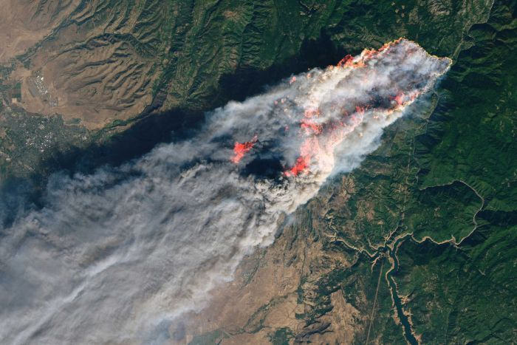Photo: California has been plagued by wildfires in recent years, but the causes are down to weather conditions and human factors. (NASA via AP)

So what is causing the California forest fires then?
The west coast state has long been susceptible to forest fires, and more than 100 people have been killed by blazes in the past 18 months.
Aside from the current Camp Fire, three separate fires in 2017 also rank among the top 20 most deadly in the state's history.
Ms Valachovic told the Washington Post California's climate and community design contributed to the blazes, along with faults in powerlines and other electrical equipment.
Two electric utilities companies said they had problems with equipment close to where the current blazes broke out around the time they were reported.
Mr Trump is a noted climate change sceptic, and rejects it exacerbates the conditions which lead to fires.
"Maybe it contributes a little bit but the big problem we have is management," he told Fox News.

Here's how Mr Trump's comments have gone down in Finland
Finns have been enjoying being thrust into the world's media spotlight by Mr Trump, even if he has the wrong impression about their country.
Hashtags playing on some of Mr Trump's famous slogans were trending on social media in Finland, with many Finnish users making memes around #rakenews and #rakeamericagreatagain.
They also have no idea how the small population could rake vast swathes of forest.

