SUBMISSION
Supplementary information

Regulatory Impact Statement
&
draft Environmental Management
And Pollution Control
(Smoke) Regulations 2017

EMPC (Smoke) Regulations Review
Environmental Policy & Support Services
EPA Tasmania
Department of Primary Industries, Parks, Water and Environment
GPO Box 1751
Hobart Tasmania 7001
EnvironmentEnquiries@environment.tas.gov.au
29th June 2017
cleanair@cleanairtas.com

EMPC (Smoke) Regulations Review
Environment Policy & Support Services
EPA Tasmania.
EnvironmentEnquiries@environment.tas.gov.au

Dear Sir/Madam,

Would you kindly add the following information to the Cleanairtas Submission emailed to you yesterday.

These photos were taken just today of a backyard burn.
The person was attempting to burn green wet waste and the smoke travelled to other residences, the aged care complex, village and shopping centre in Grindelwald.

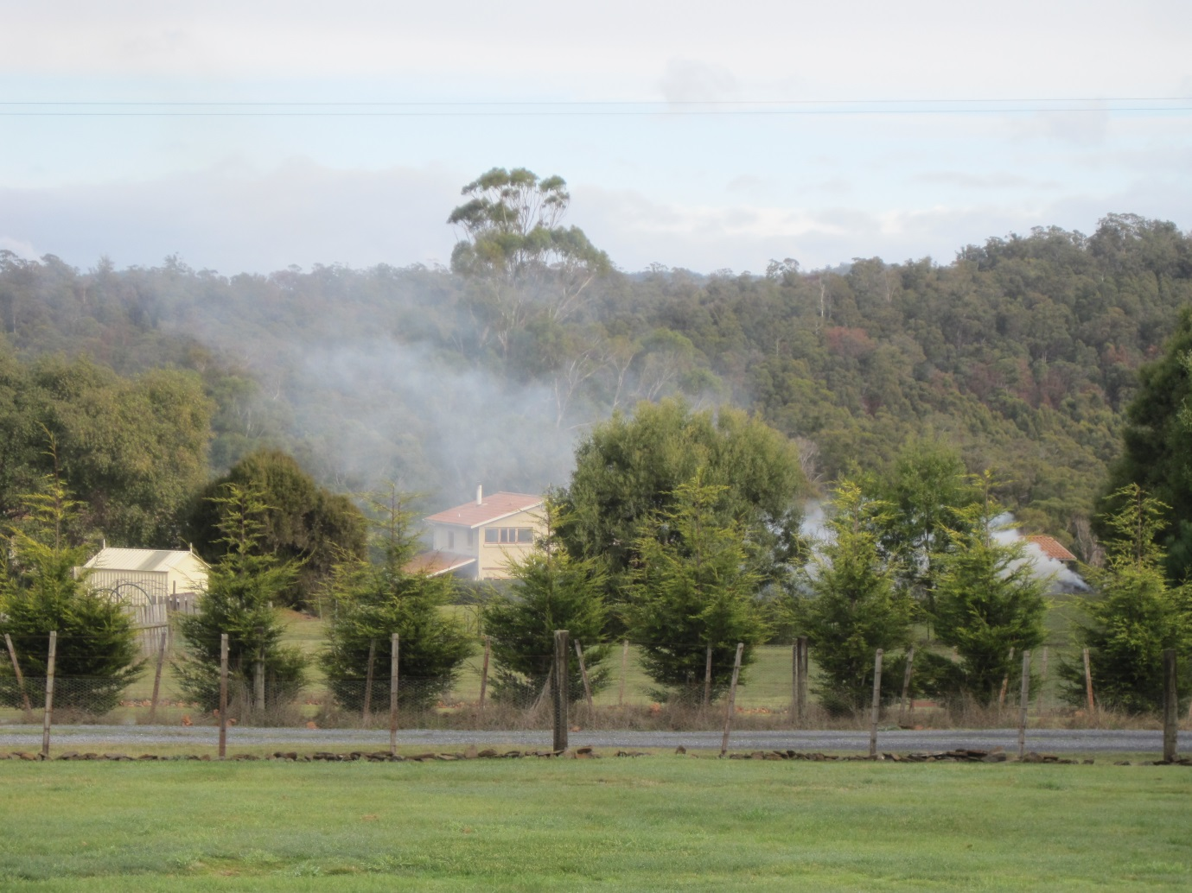

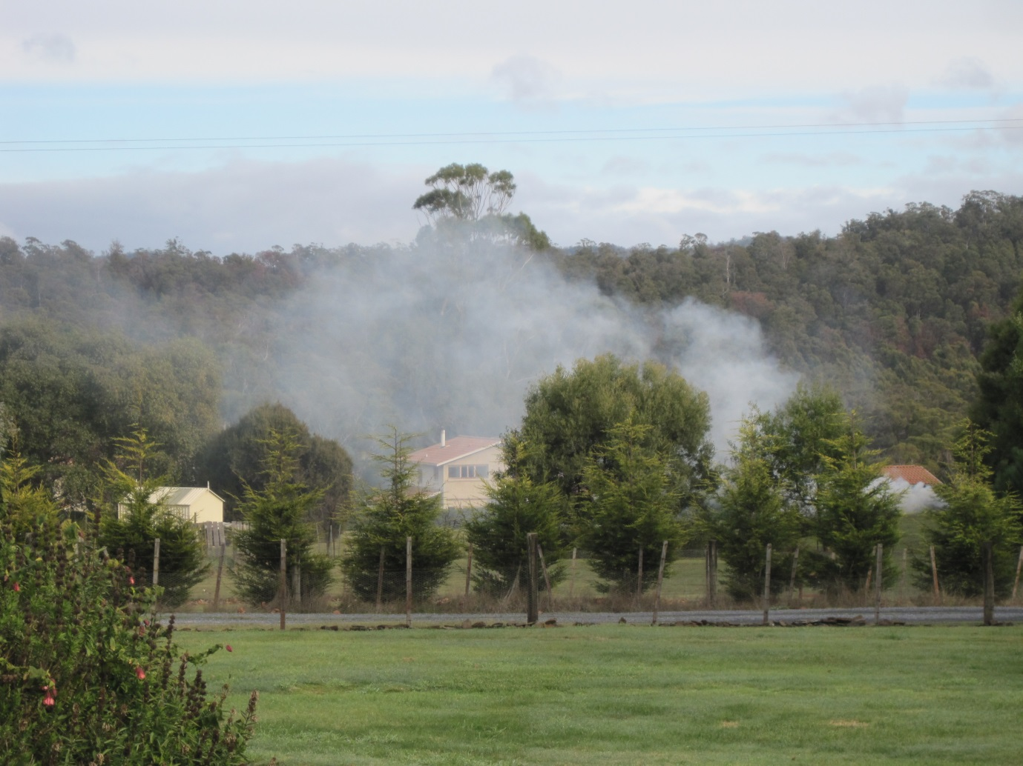

Thank you.

Yours faithfully,

Clive M. Stott for Cleanairtas

