WA rents firefighting aircraft to combat climate change-driven bushfire threat
ABC South West WA
/ By Georgia Loney
Posted 6h ago, updated 2h ago 19/4/2022
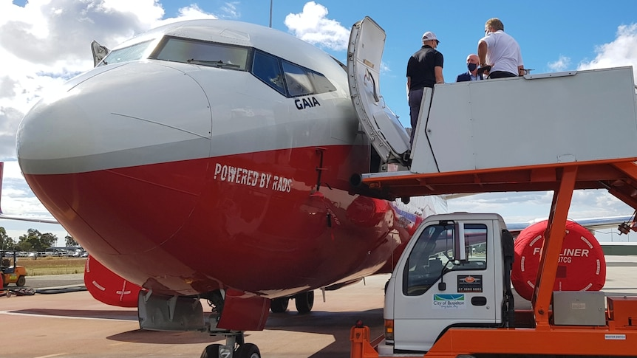
The tanker will be kept in WA over summer.(ABC South West: Sam Bold)
Help keep family & friends informed by sharing this article
abc.net.au/news/wa-spends-11m-on-firefighting-aircraft-as-bushfire-risk-worsens/100999922
COPY LINKSHARE
The West Australian government will spend $11 million to rent a large air tanker after having to borrow aircraft from the eastern states during the most recent "extraordinary" bushfire season.

Key points:
- The large air tanker can drop 15,000 litres of retardant at once
- Planes can take up to 24 hours to reach the state in times of emergency
- The WA government says renting its own aircraft is a crucial part of the response to more severe bushfire seasons
Emergency Services Minister Stephen Dawson said large air tankers were used several times last summer, which stretched firefighting resources to the limit.
In February, firefighters had to battle simultaneous large blazes at Bridgetown, Corrigin, Denmark and Wickepin, in the south of the state.
Mr Dawson says the air tanker will be in WA from December to March.
The pre-budget announcement was made at Busselton Airport, but the government was yet to determine where the aircraft would be based.
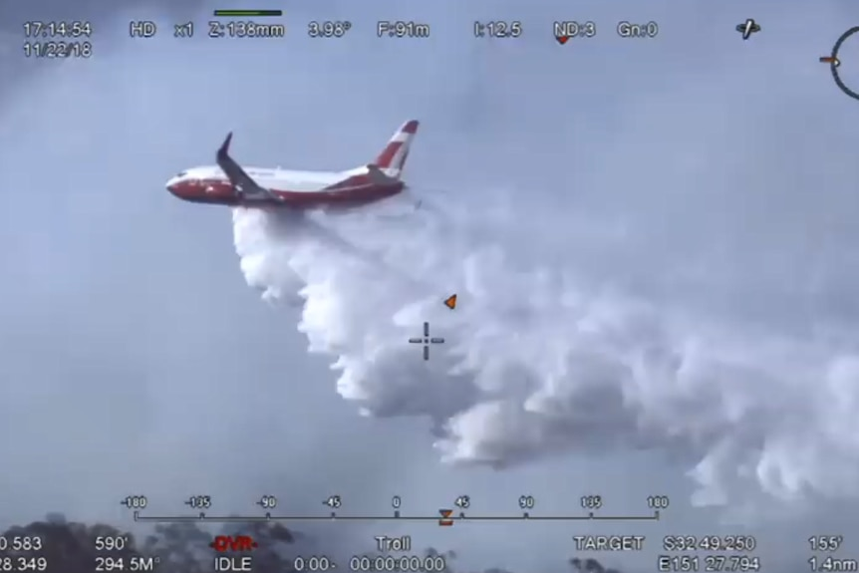
The Boeing 737 is Australia's biggest firefighting aircraft.(Supplied: New South Wales Rural Fire Service)
Mr Dawson said securing the aircraft would allow for a quicker response to big fires.
"It's been a tough year — in February we had four level three bushfires at the same time," he said.
"We had to borrow craft from from over east.
"In certain circumstances, those aircraft take about 24 hours to get here."
Mr Dawson said the tanker would be able to drop about 15,000 litres of retardant at a time, providing a significant boost to firefighting efforts.
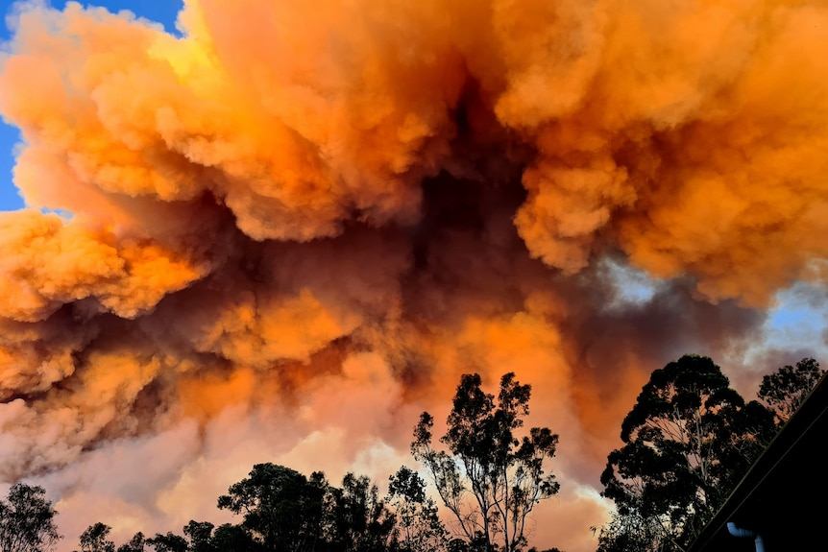
The Bridgetown fire viewed from Little Hill Farm on February 6 this year.(Facebook: Little Hill Farm)

New era of 'extraordinary' risk
Mr Dawson said the recent fire season showed the devastating impact of climate change, with major fires burning at the same time in four towns.
"That's extraordinary," he said.
"Anybody who's been in this business for a long time tells me they've never experienced that before.
"It does seem that with a drying climate, there are more risks.
"We need to make sure that we have the equipment and the resources available."
Mr Dawson said the agreement also included staff, to operate the large air tanker.

Find more local news
- Tell us your location and find more local ABC News and information

One tool in the arsenal
The Association of the Volunteer Bushfire Brigades has welcomed the announcement, but said it also wanted the state government to look at expanding the number of Black Hawk firefighting helicopters.
President Dave Gossage said he was keen to see where the new tanker would be based.
He also noted that helicopters could be used in more emergency scenarios than a plane.
"They can do fire suppression, but they can also do rescue," he said.
"It can fly at night, it can do search and rescue … a helicopter is much more versatile than a fixed-wing aircraft.
"It's very important here that we don't get caught up in the media aura with this big jumbo jet flying through the sky, looking beautiful for photo shoots.”

