HERALD SUN

**Pulp mill is finally pulped**

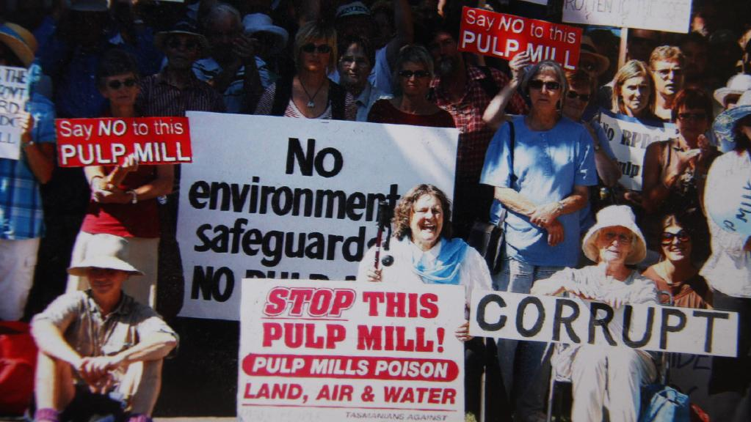

NICK CLARK, Mercury

September 2, 2017 2:00pm

<http://www.heraldsun.com.au/news/national/pulp-mill-is-finally-pulped/news-story/3d95a42a019f1e1d92a7c60ff4ed8a55>

IF they had believed in omens, the directors of Gunns Limited may have given away plans for a pulp mill in Tasmania at an early stage.

The controversial mill, which dominated Tasmanian political discourse for nearly a decade, got off to an inauspicious start in 2003.

Gunns Limited managing director John Gay and then deputy premier Paul Lennon were spotted having dinner in Hobart and, lo and behold, on the table was a folder marked “pulp mill proposal”.

A sharp-eyed diner referred the finding to then Greens leader Peg Putt, who informed Parliament.

The Gunns proposal came some 10 years after a pulp mill proposal at Wesley Vale was abandoned, in the process launching the career of former Australian Greens leader Christine Milne.

One of Gunns’ directors was former premier Robin Gray, who had lost power in 1989 as the Wesley Vale protests ramped up and Green independents formed minority Government with Labor.

Gunns was a profitable company worth about $1.6 billion on the ASX, which made big money from the export of up to five million tonnes a year of native forest woodchips to Japan.

Not long after announcing plans for the $1.3 billion pulp mill, Gunns announced a spectacular $105 million profit.

But Gunns was not a popular company and its managing director and chairman Mr Gay was known for his forthright manner.

In December 2004, the company chose to launch legal action seeking $6 million against 20 individuals and organisations critical of Gunns. They became known as the Gunns 20.

The move seemed to galvanise and motivate the opposition to the company and the pulp mill, and rallies of up to 10,000 people, featuring influential people such as gardening guru Peter Cundall, took place over the next three years.

One of the most fateful decisions, in February 2005, was Gunns’ choice to build the mill at Long Reach in the Tamar Valley, later described as Bell Bay because it was more palatable to be in an industrial zone.

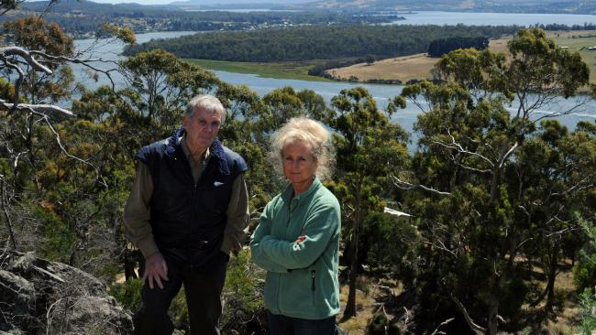

Anti-pulp mill campaigners Peter Cundall and Lucy Langdon-Lane at Brady's Lookout high above the Tamar River outside Launceston.

Tamar Valley residents had a history of being concerned about their environment and a few years earlier had protested strongly about a less intrusive fish farm. They doubled down and a Tamar Residents Action Committee was formed.

The rationale for choosing Long Reach was never fully explained, but it was said that a reason for not choosing the rival site at Hampshire, south of Burnie, was that it might be seen by tourists from Cradle Mountain. Long Reach was also just half an hour from Gunns’ headquarters in Launceston and was closer to the sea for disposing of effluent.

The State Labor Government appointed a pulp mill assessment panel within the Resource Planning and Development Commission (RPDC) to assess the plan and hearings began in 2006.

In January 2007, the then chairman Julian Green and panel member Warwick Raverty resigned, citing interference from the State Government-appointed Pulp Mill Taskforce. Former Supreme Court Judge Christopher Wright was appointed to chair the RPDC panel.

The RPDC process required Gunns to undertake a massive amount of research including a 7500-page draft Integrated Impact Statement and the timeline blew out at a cost that Gunns said was $1 million a day.

One of the critical turning points in the saga was in March 2007, when Gunns withdrew from the RPDC process. Shortly after the Government introduced fast-track legislation named the Pulp Mill Assessment Bill.

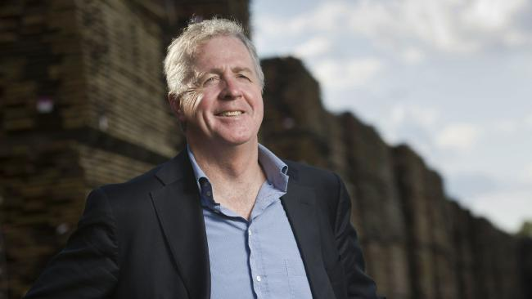Gunns managing director Greg L'Estrange, at a mill in Launceston.

It later emerged that the RPDC had considered Gunns critically non-compliant with the environmental guidelines.

The move boosted the opposition to the mill and it became a fight about democracy and process as well as a battle against the mill, which had been attacked because of its chlorine bleaching process, use of native forest timber, vast amount of log trucks across Tasmania, huge water usage and effluent outfall into Bass Strait.

But perhaps the most damaging claim against the mill was that “malodorous raw sulphate turpentine” would be able to be smelt up and down the Tamar Valley, despite Government claims that it had set the world’s toughest guidelines.

At one rally a cancer stricken Launceston General Hospital surgeon, Peter Hewitt, summed up the mood.

“This process has been a damn fake,’’ he said.

“I think it is an absolute personal insult that they should think I am so brainless that I am going to accept the process that this mill has been subjected to.

“They think the electorate are a bunch of idiots and that is what upsets me more than anything else and the fact that democracy is a word they don’t know how to spell.’’

Once the Pulp Mill Assessment Bill passed, the issue became as much about Gunns’ attempt to raise the finance in a world affected by the Global Financial Crisis as its failure to achieve a social licence.

The cost of building the mill blew out over time to $1.45 billion and then eventually as high as $2.3 billion. Gunns’ bankers ANZ informed the company in May 2008 that they would not finance the mill.

Mr Gay sought joint venture partners and in June 2009 nominated Swedish pulp mill company Sodra as the favoured partner.

But Sodra fell by the wayside because they had wanted a chlorine-free mill based on plantation feedstock and Forest Stewardship Council certified wood.

All the while Gunns’ profits had been falling because the Japanese had been turning away from native forest woodchips, it kicked an own goal with an expensive purchase of softwood sawmiller Auspine and did some curious diversification such as into wine growing via managed investment schemes.

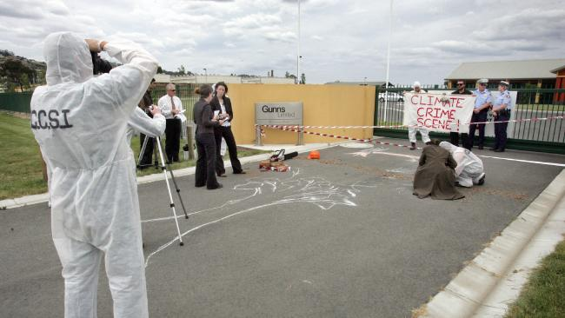Anti-pulp mill protest outside Gunns Limited head office in Launceston. Members of the group Climate Crime Scene Investigation Unit act out a mock crime scene.

The company bet its future on the $520 million of earnings before interest and tax of the mill as its debt climbed and shares slumped to as low as 17.5 cents. Several trading halts would follow in coming months.

In 2010-11 the company recorded a $355 million loss.

Another blow for the company was the charging of Mr Gay for insider trading after he sold $3 million worth of shares in 2009 while having knowledge of Gunns’ cash flow.

In February 2012, a last-gasp potential white knight emerged in the form of reclusive New Zealand billionaire Richard Chandler.

But after carrying out due diligence he disappeared with barely a word.

The withdrawal was Gunns’ last chance. It was placed into receivership and then liquidation shortly after recording a $904 million loss in September 2012. Total liabilities were around $3 billion.

Receivers Korda Mentha sold plantations worth $330 million but new owner New Forests was quick to tell the Mercury that it did not expect to be supplying a pulp mill with feedstock.

It tried several times to sell the pulp mill site and the mill licences which had cost the company $230 million to advance.

This week permits to construct the mill, extended by the Government in 2011, lapsed and Korda Mentha conceded saying there was no chance of a pulp mill at the site.

The saga had ended.

Originally published as [Pulp mill is finally pulped](http://www.themercury.com.au/news/politics/pulp-mill-is-finally-pulped/news-story/3d95a42a019f1e1d92a7c60ff4ed8a55)