http://www.examiner.com.au/story/5028999/the-pulp-mill-is-over-state-growth-minister-peter-gutwein/?cs=95

Tamar Valley pulp mill over: Peter Gutwein

Matt Maloney
Local News
November 1 2017 - 6:30PM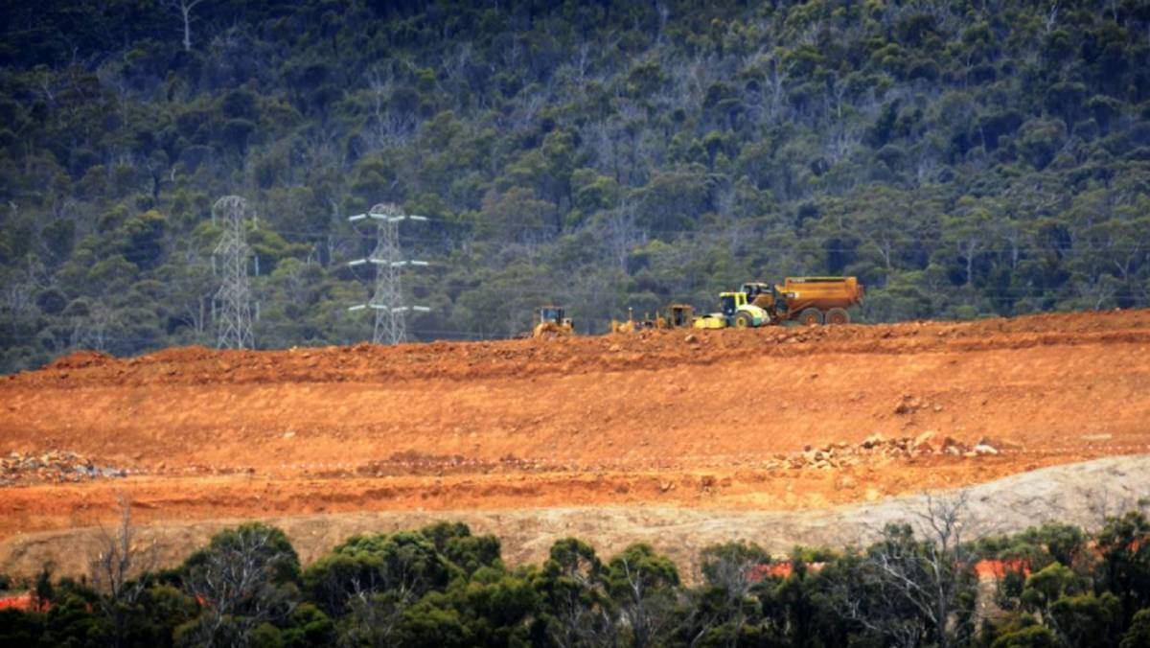
Gunns had intended to build a pulp mill at this site at Long Reach until it went into receivership in 2012.
State Growth Minister Peter Gutwein says Gunns’ receiver KordaMentha has surrendered its pulp mill permit, meaning the project now cannot proceed.
The news was revealed in Parliament on Wednesday night as the lower house debated a bill brought by the Greens to repeal the Pulp Mill Assessment Act.
The bill was moved by Bass Greens MHA Andrea Dawkins to kill off the project for good.
Former timber company Gunns had been wanting to build a $2.3 million in the Tamar Valley before it fell into receivership in 2012.
Under the act, the permit to build the mill could be sold by its receiver up until this year.
Mr Gutwein said correspondence was received from KordaMentha on September 11, surrendering its license to proceed with a pulp mill.
“The bill, therefore, is entirely redundant … as the permit no longer exists as a result of the surrender,” Mr Gutwein said.
“As far as we are concerned, the pulp mill project is over.”

