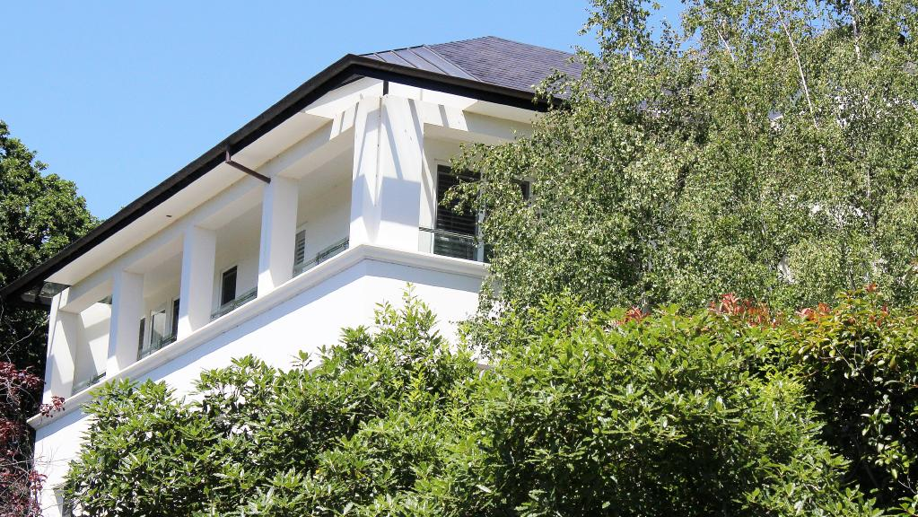The home belonging to former Gunns boss John Gay at 7 Clarence St, East Launceston. Picture: BRUCE MOUNSTER

Tasmania

Ex Gunns boss John Gay’s East Launceston home for sale at $2.5m
NICK CLARK, Mercury
January 27, 2017 12:00am

FORMER Gunns Limited executive chairman John Gay has put his Launceston home on the market for $2.5 million.
Surrounded by trees and a lush garden, the house has five bedrooms, four bathrooms and a six-car garage.
If it goes for the full asking price, it will be the most expensive house ever sold in Launceston, according to Real Estate Institute of Tasmania records.
Launceston real estate agents Bushby Property Group describes the house at 7 Clarence St as an “elegant jewel in the heart of East Launceston”.
“This stunning world-class estate constructed of only the finest materials and featuring exquisite craftsmanship offers you that true ‘Raffles’ feel,” it states.
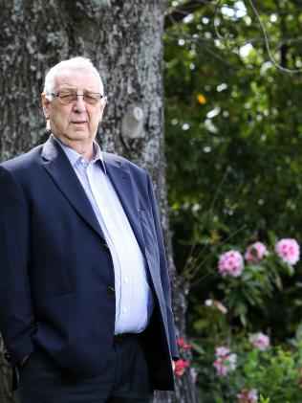John Gay, the former head of the Tasmanian timber company Gunns, in his garden at Launceston late lat year. Picture: CHRIS KIDD
Mr Gay did not want to comment about the sale which is listed on realestate.com.au.
“It’s my business. I’m out, I’m retired and it is just bloody rude to ask,” he said.
The Gunns Limited 2008 annual report discloses that a division of Gunns Limited undertook construction services worth $758,772 for Mr Gay in 2008 and $75,118 in 2009.
Mr Gay, who is believed to have serious health problems, had Gunns shares, once worth more than $50 million, when Gunns collapsed in 2012.
He pleaded guilty in the Supreme Court in Launceston to one count of the offence generally known as insider trading on December 2 and 4, 2009.
Mr Gay sold $3 million worth of shares while having knowledge of a Gunns management report.
Justice David Porter said Mr Gay’s plea of guilty was entered on the basis that he was a person who possessed inside information which he ought reasonably have known satisfied the definition of inside information.
“In other words, he ought to have known that the information was price sensitive,” he said.
Mr Gay was originally fined $50,000. But when the Commonwealth Director of Public Prosecutions sought more under the Proceeds of Crime Act, he agreed to pay $500,000.
Originally published as Former Gunns boss selling ‘elegant jewel’

