What would you do if you found out you were, or had been, breathing asbestos, arsenic, formaldehyde, or mustard gas?
These were all classed as Group 1 carcinogens (the highest level) by the cancer arm of the World Health Organisation (the IARC) back on the 17/10/2013.
They all cause cancer in humans.
I am sure you would be very angry and would complain to those responsible for the emissions.
So what would you say or do when you learn you have been breathing another Group 1 carcinogen, i.e. Particulate Matter?
Wood smoke is mostly made up of Particulate Matter, or PM2.5

Come Down For Air
Tourism Tasmania’s motto is ‘Come Down For Air’
Click on the boxes below…

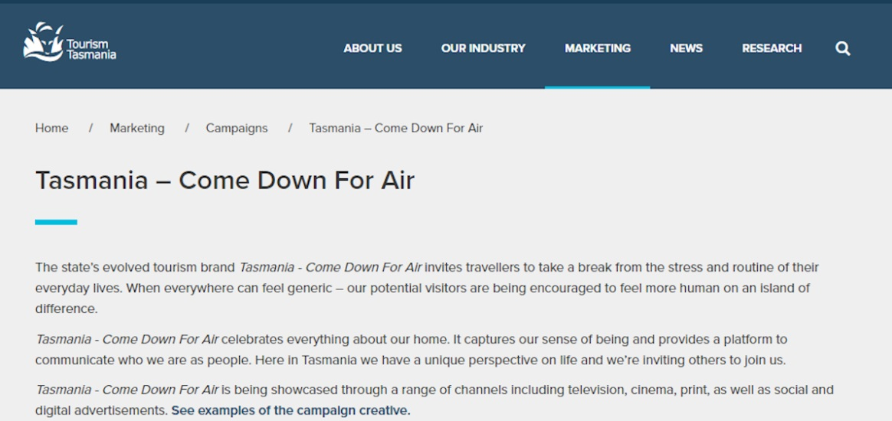

Tourism Tasmania wants people to come down to Tasmania to breathe smoke.

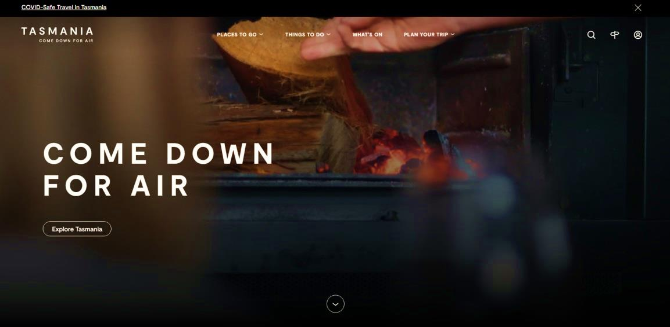

And it is supported by the government.
Heath must come before pernicious smoke.
When you can’t breathe nothing else matters.
https://cleanairtas.com/smokewatch/Burning_the_%20Masked_Owl-%20The_Weekly_Times.wmv

https://cleanairtas.com/smokewatch/7_Nightly_News-24.6.2022.wmv

https://cleanairtas.com/smokewatch/7_Nightly%20News-9.7.2022.wmv

https://cleanairtas.com/smokewatch/Bridport_skate_Park31.7.2022.wmv

