https://www.emv.vic.gov.au/news/victorias-aerial-firefighting-fleet-ready-to-protect-communities

Victoria’s aerial firefighting fleet ready to protect communities
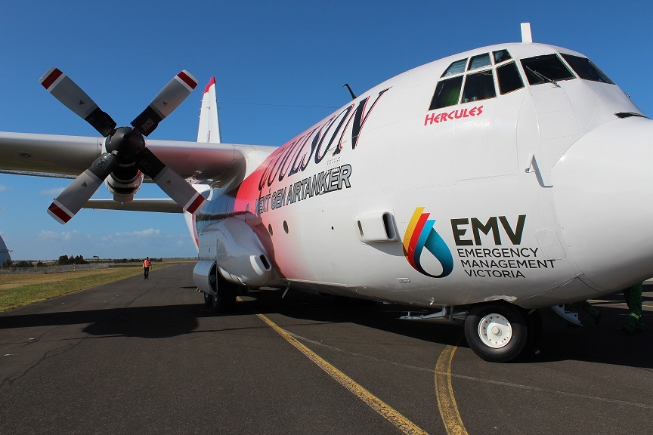
9 September 2018
Victoria will welcome back its aerial firefighting fleet this summer, with a suite of 49 aircraft available to help protect communities.
The aerial firefighting fleet for 2018-19 includes two Large Air Tankers which can carry up to 15,000 litres of water, foam or retardant, and two Air-Cranes, which are able to carry 7,500 litres of water and are essential to supporting other aircraft strategically positioned across the state.
The fleet for 2018-19 will see two upgraded aircraft, which means they have a larger capacity to hold water or retardant. One of those will be based in the Wimmera and the other at Ballarat.
At Ballarat, the capacity of the aircraft has doubled in size – from 1500Lt capacity to almost 4000Lts. The aircraft size had to change to accommodate night vision capability to further support phase two of the Victorian led night fire suppression trial.
Emergency Management Commissioner Andrew Crisp said that the aerial firefighting fleet each year has proven to be crucial in stopping the spread of fire, by providing immediate response in the early stages, supporting our firefighters on the ground.
Victoria will continue to operate firefighting aircraft as immediate response or pre-determined dispatch in locations across the state.
“The capacity for immediate response across Victoria is extremely successful in minimising the impacts of bush and grass fires on communities,” Mr Crisp said.
“Immediate response using aircraft in early stages of a fire is one of the most effective ways to help stop the spread of fire and help to keep our communities safe,” Mr Crisp said.
Mr Crisp said that aircraft would come online progressively as fire risk increases.
Victoria can also access around 100 additional aircraft as required, and can also share aerial resources from other states if needed.
Warmer and drier conditions suggest the fire season in Victoria is likely to start earlier than usual and be more active than normal. The outlook indicates Victoria will have a “normal” fire season, however, in East Gippsland conditions appear to be above normal.
The Southern Australia Seasonal Bushfire Outlook, developed by the Bushfire and Natural Hazards Cooperative Research Centre with Bureau of Meteorology and relevant state fire and land managers, was released in Perth this week.
Read our news story (External link) about the seasonal forecast for Victoria.

