Smoke pollution from wood heaters is a major health concern for some cities, particularly Launceston.

Councils prefer education and cautions rather than fines for wood smoke pollution
CHRIS PIPPOS, Mercury
June 8, 2017 9:00pm
LAUNCESTON City Council has rejected powers to fine households up to $1300 for emitting toxic woodheater smoke, despite receiving 131 complaints over the past four years and a code red being issued about the region’s air quality.
The Environment Protection Authority’s air quality data on Thursday recorded Launceston as the only location out of 20 in the State to have high smoke levels, meaning asthmatics were told to stay indoors.
However both Launceston and Hobart city councils have told the Mercury that issuing cautions and educating households is the best way to deal with complaints about toxic smoke and green wood-fired, smouldering domestic fires.
Council environment officers were given the power to issue $240 on-the-spot fine or a $1300 maximum in 2012.
The councils’ comments coincide with new regulations proposed by the State Government allowing council and EPA officers – from mid-August – to issue an immediate fix order over smoke emissions that upset neighbours.
As reported in last weekend’s Sunday Tasmanian, households that are the subject of a valid complaint are currently given a 21-day order to fix the woodheater smoke problem.
MORE: EPA TO TARGET THOSE BURNING GREEN AND TOXIC FIREWOOD
Arguably the worst council region for woodheater smoke, Launceston has received 131 complaints, issued 35 cautions and provided 70 education pamphlets since 2014.
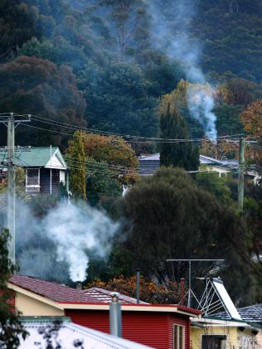
Both the Launceston and Hobart city councils say issuing cautions and educating households is the best way to deal with complaints about toxic smoke.
This does not include complaints made directly to the EPA, which largely handled industrial smoke nuisance.
Launceston City Council general manager Robert Dobrzynski said issuing fines was not the best way to achieve a better outcome.
“Where we can identify individual properties that are the subject of complaints, we attempt to discuss the issue with the owners and provide some educational material on efficient use of woodheaters,” Mr Dobrzynski said.
“In some circumstances, we will issue caution notices.
“While we don’t keep statistics on the causes of woodheater smoke issues, common causes we see are poor maintenance of flues and the burning of wood that is not dry.
“We find that woodheater owners, on the whole, want to do the right thing by the environment and their neighbours.”
Hobart City Council has received 49 complaints about woodheater smoke since 2012.
“The majority of complaints are resolved through the issue of a caution letter, which includes information and educational materials on how to burn appropriately and what the laws are,” a Hobart City Council spokeswoman said.
“There have been no infringements or court action in the last five years.
“The problem is usually related to woodheaters left smouldering instead of being burnt hotter.
“Once people understand how to burn brighter, a slogan from the ongoing EPA education campaign, the smoke nuisance tends to reduce.”
The Burn Brighter Education campaign was first undertaken in East Launceston and West Hobart in the winter of 2012.

