

September 20 2019 - 7:30AM

**Tasmania remote area firefighting suspension could be resolved by summer**

[Adam Holmes](https://www.examiner.com.au/story/6396468/remote-area-fire-issues-could-be-resolved-by-summer/)

[Adam Holmes](https://www.examiner.com.au/profile/118/adam-holmes)

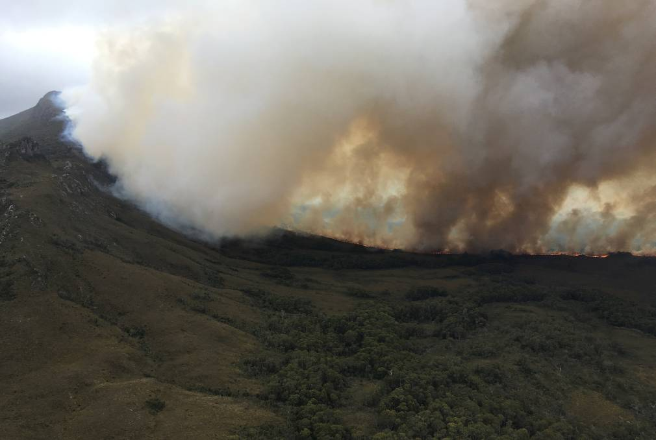

A bushfire in the Wilderness World Hertage Area in January. Picture: NSW RFS

Tasmania's emergency management minister is confident that a suspension on remote area firefighting teams will be lifted in time for summer, but other measures are also being considered.

Tasmania Fire Service remote area teams were suspended due to concerns over Work Health and Safety breaches, with a provisional improvement notice in place for evacuation procedures.

It means that only Parks and Wildlife can deploy their remote area firefighters, and assistance could be called in from the mainland if a fire escalates beyond the PWS capabilities.

Minister for Fire and Emergency Management Mark Shelton said he was confident the TFS issues would be resolved before the summer fire season.

**MORE ON FIREFIGHTING IN TASMANIA:**

[**Questions over proposal to establish volunteer remote area firefighting teams**](https://www.examiner.com.au/story/6319870/volunteer-remote-area-fire-teams-draws-questions/?cs=95&fbclid=IwAR3sWsBxGnbUiOjKpGJUyLeTqMa6CiNWMgQuodWvjxX8vahm1SHzCvYXarE)

[**Review of the 2019 bushfire season released**](https://www.examiner.com.au/story/6318100/units-thought-fire-was-out-report/)

[**Not the Norm: TFS State Conference puts climate change front and centre**](https://www.examiner.com.au/story/6181623/not-the-norm-tfs-bracing-for-worsening-fire-reality/)

[**East Coast at greatest risk as fire season approaches**](https://www.examiner.com.au/story/6395503/east-coast-at-greatest-risk-as-fire-season-approaches/)

"The PINs (provisional improvement notices) are in place at the moment, and the chief fire officer is working through the issues within the PINs, and he's indicated that come the coming fire season that those issues will be resolved," he said.

"But until that happens, the predominant workforce is Parks and Wildlife and they have the predominant workforce in remote area firefighting activity anyway.

"If the fire does escape and is substantial, then the national arrangements come into place where we can get assistance from the mainland."

The United Firefighters Union has been pushing for a resolution since the ban came into place, fearing the lack of specialist TFS remote area teams could place the community at risk if a fire season similar to 2018/19 occurs.

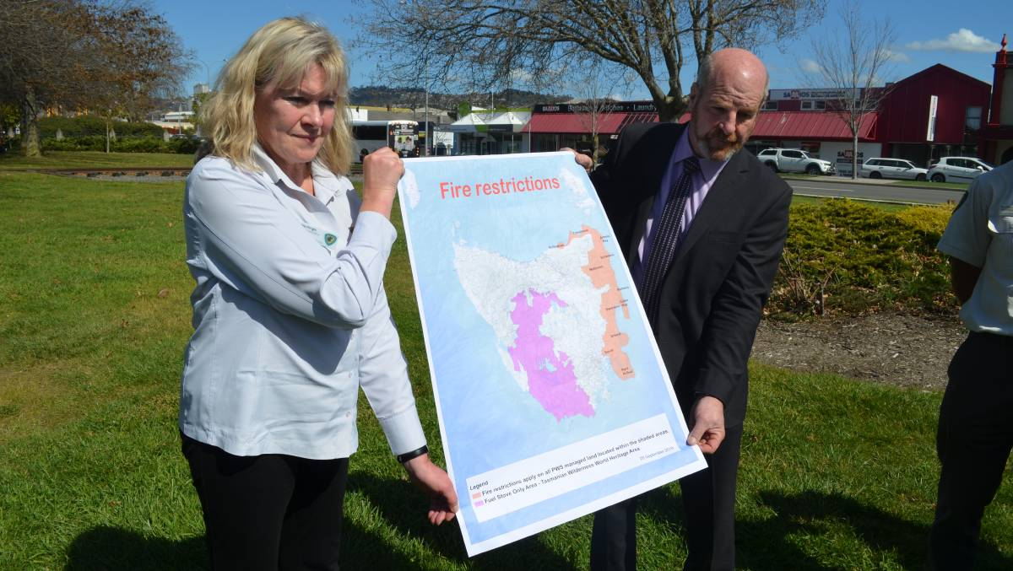

TFS acting deputy chief Sandy Whight and Police, Fire and Emergency Management Minister Mark Shelton with the fire restrictions map. Picture: Adam Holmes

A review into the fire season, conducted by the Australasian Fire and Emergency Service Authorities Council, [recommended establishing volunteer remote area firefighting teams](https://www.examiner.com.au/story/6319870/volunteer-remote-area-fire-teams-draws-questions/?cs=95&fbclid=IwAR3sWsBxGnbUiOjKpGJUyLeTqMa6CiNWMgQuodWvjxX8vahm1SHzCvYXarE).

Mr Shelton said this was a range of suggestions being considered.

"It's part of the whole issue, our program is looking at the best way of introducing remote area firefighters, and it's been talked about - the volunteer remote area firefighters, similar to NSW," he said.

The opening of the fire permit period [has been brought forward to September 28](https://www.examiner.com.au/story/6395503/east-coast-at-greatest-risk-as-fire-season-approaches/) in three Tasmanian council areas on the East Coast.