11th May.2019
Oregon - Tiller Trail Highway Fire – DFPA Photos.

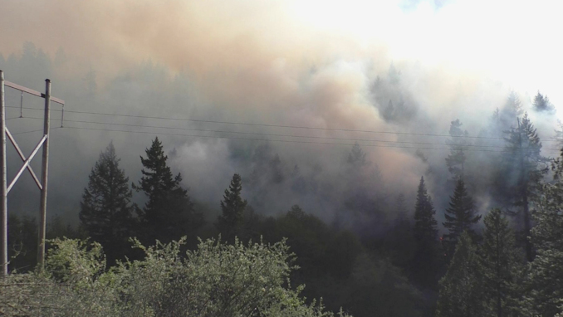

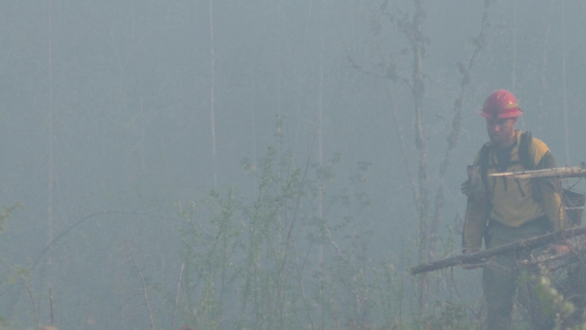

Oregon: It is unbelievable how fire fighters get out in this smoke without wearing masks.
AND you need to be clean-shaven to get a good face-fit when you wear a face mask so it does not leak smoke into your lungs.
If they are not worried about their own health they are not going to worry about yours!
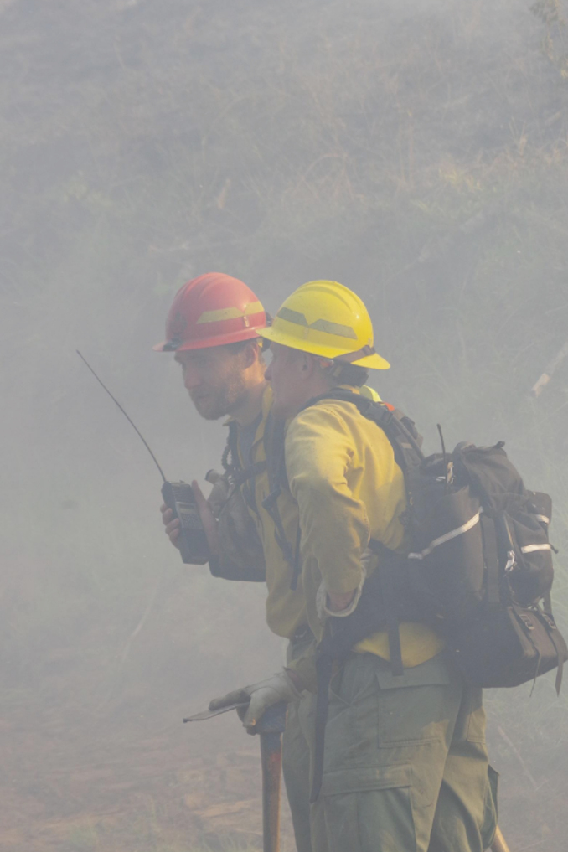
https://kpic.com/news/local/gallery/tiller-trail-highway-fire-videos-show-conditions-on-ground-friday#photo-3

11th May 2019 Oregon:- Cottage Grove Fire

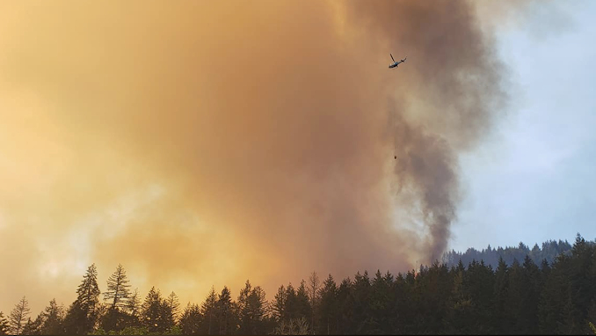
Man made forests and man-made fires: - Photos from Facebook contributors.
Here you can just see a tiny Bambi Bucket on the end of a string attached to the helicopter.
Trying to put out a fire of this size with this equipment is ridiculous. No wonder people are breathing so much smoke before the fire is completely extinguished.
Oregon has a lot to answer for with their fires, smoke and climate change.
Get in early, put the fires out before they spread, and go home!

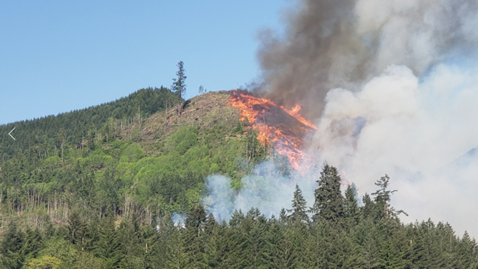
Sure looks like a deliberate burn to get rid of forest waste after logging.
Pity about the cancerous smoke!
https://kpic.com/news/local/gallery/fire-outside-cottage-grove-sends-up-towering-plume-of-smoke#photo-6

Mark Graw with the U.S. Forest Service says, “Fire prevention equals smoke prevention. I don’t think people always equate those two”

Two things cause wildfires: Lightning and humans.

In 2018, three quarters of the wildfires across the United States were started by people. Almost all of the Northwest fires so far this year were too.
https://kpic.com/news/local/where-theres-fire-theres-smoke-the-dangers-of-wildfire-smoke

