**Submission**

National Plan for Clean Air Project

**Consultation Regulation Impact Statement for reducing emissions from wood heaters.**

8th June 2013



Contact: Clive M. Stott

9 Alpine Crescent

Grindelwald

Tasmania. 7277

To: COAG Council on Environment and Water

[scew.secretariat@environment.gov.au](mailto:scew.secretariat@environment.gov.au)

Why should Cleanairtas even bother making a submission in relation to wood heaters?

This is the question we are asking ourselves.

I live in the Tamar valley. Practically everyone has heard of the Tamar valley, or the city of Launceston in the Tamar valley, when it comes to air pollution. This is where 100,000+ pairs of lungs go about filtering the deliberately polluted air that hangs around in this beautiful valley.

On the 3rd June 2013 I filed a smoke pollution complaint with my local council. I became very ill again after inhaling harmful particulates. Yes, it was for one of many harmful back yard burns I have been dealing with but it is connected in so many ways with emissions from wood heaters.



Smoke from this back yard burn equates to the smoke from many, many wood heaters.

One compliant wood heater can give off as much as 4g/Kg of particulates for every Kg of dry wood burnt. Imagine how many tonnes of fine particulates were released throughout the duration of this deliberate burn.

This was the reply I received back from my West Tamar Council:

Mr Stott,

I have investigated this complaint and consulted with EPA on this matter also. The fire which you refer to was not illegal as it comprised branches and other green waste on a property larger than 2000 square metres, nor would it constitute an unreasonable interference with another person's enjoyment of the environment.

No further action is proposed in regard to this matter.

Yours faithfully,

Rick Chippindall

Senior Environmental Health Officer

Depending on the source and wind direction, this smoke does not always register on fixed air monitoring stations until it shows up in the mix in Launceston. - EPA Tasmania - wind roses.

Smoke also comes into the Tamar valley from Victoria. – EPA Tasmania.

**"In 2008 forest industry planned burns were likely to have contributed to the Tasmanian air shed between *seventeen* and *twenty four* times the particle pollution produced by domestic wood heaters (86,000 to 122,000 tonnes from planned forest burns compared to 5,000 tonnes from domestic heaters)." - EPA.**

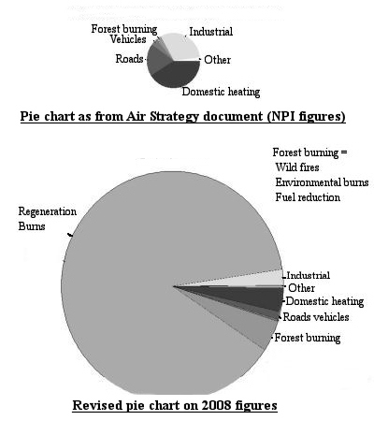

Wood heater owners feel they are being unfairly blamed for much of the particulate matter in this state and they are probably right, but….

The breathable particulates wood heaters produce can be extremely harmful to everyone who comes into contact with them.

Launceston is in a river valley. It experiences temperature inversions, and any rise of particulate matter (PM) of any duration, is harmful to its people.

I refer to the [Distributed Atmospheric Emissions Regulations 2007 – Implementation Evaluation Report 2010 (PDF, 174KB)](http://epa.tas.gov.au/Documents/DAE_Regulations_2007_Implementation_Evaluation_Report_2010.pdf) prepared by the EPA:

**Survey**

“The results of the August 2008 survey of Tasmanian councils were presented in a report in October 2008. The results were summarised as follows.

Between the two reporting years, complaints about smoke from heaters and the like

decreased, but the number of complaints about backyard burning and prohibited fuel

increased.

Councils generally do not have the resources to be proactive in this area. While they

will respond to complaints, proactive implementation is a low priority.

Councils do not see it as their role to educate the public about the regulations.

Council officers are likely to continue to use existing enforcement regimes under the

EMPCA (in addition to, or instead of, the regulations).

In relation to community public relations, councils are in an invidious situation while

large scale burn-offs continue.”

So there we have it.

According to our Local Government at present their advice is one can burn as much freshly cut, green, smoky waste, as you like in Tasmania on blocks of land upwards of 2000 square meters. (half an acre, or, 2 to 3 domestic building blocks of land).

If you are one of a susceptible group, i.e. those with respiratory or cardiac diseases, children, or the elderly, nothing will be done about it for you despite all our environmental legislation.

**Tasmania needs to be made to conform to tighter national air quality standards.**

The point I am making is this. Whilst we are here discussing a RIS in relation to harm caused by wood heaters, free rein is granted to the producers of much bigger, more harmful, smoky burns in Tasmania, and in particular the Tamar valley and its surrounds. These large scale emissions from open burning must be addressed first for any wood heater smoke regulations to work successfully.

Why should I, for example, be allowed to go out and burn green, wet, smoky waste and wood heater owners are targeted because of my actions?

People are in charge of a lethal weapon when they deliberately fire open smoky burns or smoky heating appliances. Those in the firing line can be seriously maimed or die as a result of their actions. I am one of those people who have been seriously harmed and am still being subjected to environmental wood smoke.

In my opinion the burners should be charged with manslaughter for every death that occurs from wood smoke or the stress of fighting to end it.

**Cleanairtas maintains wood heater owners should have to be licenced after passing an approved training course in the safe handling and operation of a deadly weapon, i.e. wood heater.**

Particulates emitted from wood heaters are just as dangerous to any living plant or animal as that released from any other burning vegetation. This includes anything from forestry planned burns down to cigarettes. It is all burning vegetation and they all emit fine particulates.

The science is out there to indicate the harmful effects of wood smoke. It is published along with practically every smoke submission paper; on practically every Health and EPA website, on dedicated wood smoke sites such as, (<http://burningissues.org/car-www/index.html> ; <http://woodburnersmoke.net/> ; <http://cleanairtas.com/issmoke.htm> and our communities are being asked to go over and over this subject whilst our regulators keep tossing it about and susceptible and even healthy groups are forced to inhale this pernicious pollution.

This article is well worth reading: [Governments Role in Protecting Health and Safety](http://www.nejm.org/doi/full/10.1056/NEJMp1303819).

Listen to what three Tasmanian medical doctors have to say about wood smoke:-

Dr Fay Johnstone Tasmanian GP and Epidemiologist.

<http://www.abc.net.au/radio/player/rnmodplayer.html?pgm=Bush%20Telegraph&pgmurl=http%3A%2F%2Fwww.abc.net.au%2Fradionational%2Fprograms%2Fbushtelegraph%2F&w=http%3A%2F%2Fwww.abc.net.au%2Fradionational%2Fmedia%2F4732442.asx&r=http%3A%2F%2Fwww.abc.net.au%2Fradionational%2Fmedia%2F4732442.ram&t=Wood-burning%20stove%20pollution&url=http%3A%2F%2Fwww.abc.net.au%2Fradionational%2Fprograms%2Fbushtelegraph%2Fwood-burning-stove-pollution%2F4732442&p=1>

Video presentation by Dr James Markos, Launceston Lung Specialist, and

Dr Michael Aizen, Australian Medical Association.

<http://www.youtube.com/watch?v=jaxSgglRpLY>

If we know how dangerous wood smoke is then something needs to be done in a hurry to stop it.

The drawn out process has gone on long enough whilst people suffer and die as a result of inaction. What are we waiting for; who are we waiting for?

Air quality monitoring has gone on long enough now for something tangible to be done in relation to harmful levels of wood smoke from wood heaters.

**No amount of air monitoring is going to save one life unless the results are translated into legislation that is administered correctly and contains enforcement provisions and penalties.**

I have to travel to Launceston to attend my lung specialist and do other business. I also have to travel to Exeter to see my GP. Sometimes I have had to cancel my appointment because the wood smoke was so thick. Wood heater flues can be seen belching smoke quite regularly along these routes.

Prior to commencing this submission I sought the following information from the EPA in relation to wood heaters:

From: EPAEnquiries@environment.tas.gov.au

Subject: RE: wood heater questions

Date: Thu, 18 Apr 2013 06:36:36 +0000

Dear Mr. Stott,

Thanks for your query. Please find a reply to your questions in the email below.

**Hello EPA,**

**Can you tell me please:-**

**Q: Which body in Tasmania is responsible for administering domestic wood heater installations?**

The Building Act 2000, the Building Regulations 2004 and Plumbing Regulations 2004 regulate building and plumbing work in Tasmania. These laws and codes apply to everyone who undertakes building and plumbing work.

The Building Regulations (2004) state at sub-regulation 50 that:

**50. Heating appliances**

**(1)** A person must notify a permit authority, within a specified period after starting the installation, of his or her intention to install a stove, or a heater or similar appliance, which burns oil or solid fuel.

Penalty:

Fine not exceeding 20 penalty units.

**(2)** A person who undertakes the installation must notify the permit authority that the installation has been carried out in accordance with the Building Code of Australia within the specified period after the completion of the installation.

Penalty:

Fine not exceeding 20 penalty units.

**(3)** A notification under [subregulation (1)](http://www.thelaw.tas.gov.au/tocview/content.w3p;cond=;doc_id=%2B43%2B2004%2BAT%40EN%2B20130418000000;histon=;prompt=;rec=0;term=#GS50@Gs1@EN) or [(2)](http://www.thelaw.tas.gov.au/tocview/content.w3p;cond=;doc_id=%2B43%2B2004%2BAT%40EN%2B20130418000000;histon=;prompt=;rec=0;term=#GS50@Gs2@EN) is to be in an approved form.

**(4)** A permit authority may inspect, or cause an inspection to be made of, the installation and require that the installation be made to comply with the Building Code of Australia.

The Building Code of Australia requires that domestic solid fuel burning appliances comply with AS/NZS 4013 and are installed in accordance with AS/NZS 2918.

The Building Act 2000 indicates at clause 3(1) that a:

***permit authority*** means a person or body authorised for that purpose by the council of the municipal area in which the relevant building work, building, plumbing work or plumbing installation is located or, if the council has not made such an authorisation, the general manager of the council;

**Q: What is the position with regards to finding a registered/certified wood heater installer in Tasmania?**

**Is there a current list of approved installers?**

Currently there is no registration or certification for wood heater installers in Tasmania. As indicated above ‘a person who undertakes the installation must notify the permit authority that the installation has been carried out in accordance with the Building Code of Australia within the specified period after the completion of the installation’ and ‘a permit authority may *(then)* inspect, or cause an inspection to be made of, the installation and require that the installation be made to comply with the Building Code of Australia’.

**Q: Does the EPA or anyone else have an up-to-date figure for the number of domestic wood heaters installed in Tasmania?**

According to the most recent Australian Bureau of Statistics data the number of wood heaters in Tasmanian in 2011 was 58200 (+/- 6400).

**Q: Do we know how many comply with the current emission requirements?**

There is currently no published information on the number of wood heaters in the community that are compliant with the Australian Standard 4013.

**Q: If so, is there a breakdown of figures by location?**

There is currently no published breakdown of figures by location.

It just so happens, I recently had a new compliant wood heater installed.

The shop where I bought it is an AHHA member and uses a preferred installer.

After the wood heater was installed I checked with my council to see if the following two forms had been submitted.

This is something that most people would not consider doing I would imagine.

**Heating appliance installation notification Form 53**: <http://www.wtc.tas.gov.au/documents/Microsoft_Word_-_Installation_Notification.pdf>

**Heating appliance compliance certificate Form 54**:

<http://www.wtc.tas.gov.au/documents/Microsoft_Word_-_Compliance_Cert.pdf>

Neither form had been submitted, so I called the installer. He felt it was not necessary because it was a replacement heater and the original heater notifications would have been submitted to council.

It turns out they were not required back when the previous heater was installed.

Nobody had filled out a wood heater compliance certificate for this address. Council had no knowledge of a wood heater ever being installed at this address.

The notice to install a new heater, Form 53, went in to council 70 days after the heater was installed and only because I asked for this to be done.

I had to make it my business to make sure the Compliance Form 54 was submitted.

Council does not follow these things up. Council did suggest I follow it up myself because there could be complications with my home insurance if anything happened and there was not a completed wood heater compliance certificate lodged.

I am aware of homes with wood heaters installed that have not submitted compliance certificates.

**As loose as this all is, it is a product of our current legislation and administration, and it needs tightening in the strongest possible terms.**

The RIS contains figures for the number of wood heaters installed in Tasmania.

It is impossible to know how many wood heaters are installed in Tasmania if forms are not being completed by a registered installer and when there are no checks being done on wood heater installations.

I telephoned a registered building surveyor and asked if they certify wood heater installations as per the Australian Building Code.

The answer was they do not certify wood heater installations and to contact a registered wood heater installer. As we read previously, “Currently there is no registration or certification for wood heater installers in Tasmania.” – EPA.

Is it just Tasmania that is non-compliant? I doubt it very much.

**New compliant wood heaters:**

Take for example a new wood heater that has an emission figure of 2.6g/Kg with 59% efficiency which is well under the 4g/Kg standard for new wood heaters.

The makers have done a great job in making sure it meets the standards, but it is disappointing how much wood it burns to achieve these figures.

No way will this wood heater burn overnight. People are being forced to live in the cold by some wood heater manufactures worrying about meeting standards rather than basic wood heater operational criteria.

What good is it loading up a wood heater of a night to find it has flared away shortly into the night and when the occupants get up in the morning, or during the night, they get up to a cold house? This is ridiculous and the wood heating industry is doing itself no good by putting out such useless appliances. They deserve to lose their market share.

**Heater manufacturers should be required to declare a burn time on the compliance plate attached to the heater.**

In a two story house with cathedral ceiling the flue screen temperature a meter up from the heater measured 120 degrees C, and it also measured the same 120 degrees C right up to the top of the screen inside the second story where it penetrated the roof.

Obviously this shows much of the heat is wasted because the heat goes straight up the flue.

If heat was not going up the flue there would be a heat differential on the screen between near the heater and near where it penetrates the roof.

We are being advised to open up the damper for 20-30 minutes (depends on which article you read) when loading more fuel into the heater. [‘Burn brighter’](http://epa.tas.gov.au/documents/burn_brighter_this_winter_step_by_step_a4_fact_sheet.pdf) the message is.

I agree with the burn brighter message except for the following message and I disagree with it most strongly:

*Adding more fuel?*

*Going to bed for the night?*

*Leaving the house?*

*To ensure your fire does not create excessive smoke you must*

*burn your fuel with the air vent fully open for at least 20 minutes when adding more fuel, before turning it down for the night, before leaving for work or*

*leaving the house for any extended period.*

Unfortunately, this can be very dangerous advice in some circumstances.

In practice I have found if there is a large bed of hot coals already in the fire box and wood is added and the heater is operated with the damper fully open working temperatures can rise to a disturbing high level in the heater fire box and especially in the flue under these conditions.

I would doubt very much if this ‘burn brighter’ procedure was employed during certifying conditions for the heater and/or the flue. I feel it has been added along the way by others.

The tip off a thermocouple was burnt off trying to measure the temperature of the flue under these extremely hot conditions and I would never attempt to ‘burn brighter’ while there was a good bed of coals already red hot in the firebox for fear of a roof fire, a chimney fire, or something bursting into flames from what would be considered safe clearance distances from a normally operating wood heater installed as per the current standards.

**It is all too easy to forget the damper is wide open every time you light the heater or put another piece of wood in. You can inadvertently leave the heater to burn fiercely with your back turned and while it is fully loaded.**

**Imagine leaving the house or retiring to bed while the heater was burning flat out because you had forgotten to turn it down?**

And, I strongly disagree also with the following at <http://epa.tas.gov.au/epa/improving-wood-heater-use> in relation to overnight burning of wood heaters:

* let the fire burn itself out over night.
* Next morning light a fresh fire in the warm firebox.

Many people with disabilities are forced to use wood heating in Tasmania.

Asthmatics for example need a warm dry house free of mould which is a known trigger for asthma. Cold itself can also be a trigger.

These people should not be forced to wake up to a cold house in the morning or in the early hours of the morning when the heater has burnt itself out.

Depending on the model, in the morning the heater is usually stone cold; the firebox has no warmth left in it at all.

To have to worry about lighting the heater up again so you don’t freeze is a bit much to ask.

It is not right to advise someone to turn their heating off during the coldest hours of the day and months of the year. We would not consider doing this with other forms of heating. Their best advice is to reduce the heating, not turn it off altogether.

It can take many hours to raise the temperature from freezing in a dwelling.

This is an unnecessary use of our resources to have to fire up from cold each morning or in the night and resultant health costs to our health system will be huge down the track if this advice to let our heaters go out during the night is headed.

Many elderly people would require help to get their wood heater going again for them. Sick or elderly people are sensitive to the cold and can die of the cold.

We also know that most emissions are produced during the light-up phase of a wood burner. Every time one of these new compliant wood heaters goes out and has to be relit we considerably increase the amount of emissions given off. Further harmful emissions are given off by accelerants such as fire lighters each time it is lit.

I have observed people lighting their heaters from cold in the morning and then closing them down to go to work. They have not got time to hang about for half an hour to flare the wood up. The heaters give off smoke until late morning when they have burnt themselves out. This extends the emissions into the daytime hours when people are out and about to breathe the particulates.

We must take notice of the studies which highlight the fact that small quantities of fine particulates over a longer period of time are just as bad as high levels of particulates over a shorter amount of time. [Even Low Levels of Air Pollution Can Cause Lung Cancer.](http://www.medicalnewstoday.com/articles/263080.php)

Dr James Markos, lung specialist in Launceston, has consistently claimed this fact.

It is time our regulators started listening.

**Have we achieved anything in the total number of emissions being given off with a new compliant wood heater that needs relighting several times a day? Probably not.**

**Emergency shutdown of a wood heater:**

This brings up another point. There is no way to my knowledge of quickly starving one of the new wood heaters of oxygen if it over heats or there are other reasons to close it down in a hurry. These new certified wood heaters are designed so the air damper will not fully close.

**People have been totally fixated on combustion with these wood heating appliances and again have forgotten safety fundamentals.**

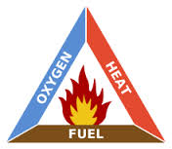

Combustion triangle

Remove any side of the triangle and the burn will extinguish.

You cannot remove the fuel, and you cannot remove the heat; the only other way to extinguish a fire is to remove the oxygen and this is impossible because a compliant wood heater is designed to maintain combustion.

**Every heater should have built into them some form of emergency damper to completely shut off all the air supply in an emergency.**

**Heaters fitted with an anti down draft cowl:**

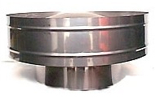

This type of cowl tends to force flue emissions down over the house during calm conditions. This is not healthy.

It is unsatisfactory to bathe the dwelling in wood smoke which then finds its way into a home because of negative pressure inside.

There are other types of cowls that can be fitted but they should be checked to see if they form part of the certified flue for a particular heater.

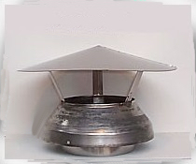

**Simple ‘chinaman hats’ tend to disperse the emissions better.**

**Wood heater emissions inside the house:**

We know that outdoor air quality impacts on indoor air quality. It has been reported particulates can be as high 60% inside compared to outside readings during short raised outdoor intervals, and rises to unity, ie 1:1 under longer exposures to polluted outside air.

It is not only outdoor emissions that effect indoor emissions; far from it.

Some new compliant wood heaters (less than 4g/Kg) are capable of producing white ‘dust’ that settles on everything in the room even when the fan has not been running. It requires meticulous vacuuming every day to get rid of it.

Occupants are breathing this harmful residue.

This factor should form part of wood heater compliance standards to make sure it does not happen.

One particular compliant wood heater keeps forcing burnt wood up to the front of the fire box, even up onto the glass at times. This makes it impossible to open the door of the heater without risking hot coals, or even a hot log, dropping onto the hearth and smoke filling the room.

Whilst the heater is in this state, proper combustion is not taking place and heavy emissions are rising up the flue to pollute our outdoor air.

It is interesting to note that some wood heaters have ‘bellows’ fitted to allow more air in at start up to get the heater burning more quickly so it produces less emissions during this start-up phase or before opening the door. Great idea.

It is important to be able to inject a stream of air to get a smouldering fire burning so the house does not fill up with harmful smoke if the door is opened, and of course to clean up harmful smoky emissions being given off outside the house.

**Some type of ‘bellows’ needs to form part of every wood burning appliance installed inside a dwelling.**

**Failing this, it should be mandatory to have an extraction fan in the vicinity of the wood heater to exhaust harmful particulates that puff into the room from a wood heater when the fire box door is opened.**

This would need to be electrically interlocked so it was not running to draw smoke out of the heater when the fire door is open.

**It is not recommended to smoke inside a house for health reasons, and yet we allow wood heaters to smoke inside a house.**

It would also be beneficial to have some form of igniter installed in the firebox so the door on the wood heater does not have to be opened to let smoke out into the room when first lighting the heater, or when the wood has died down and is then put into the ‘about to catch alight’ phase.

**The whole design of wood heaters needs looking into:**

It appears there have been attempts by some makers to meet emission and efficiency standards and these makers have been successful in obtaining compliance under controlled ‘laboratory type’ conditions.

However, it is not just good enough to put more air and more wood into a heater for it to comply.

Real-life conditions can be very different i.e., the wood, the moisture content of the wood, the length of the flue, how the fuel is loaded, air flow, etc. It would appear under compliance testing optimal conditions apply; however in the home, conditions are very different.

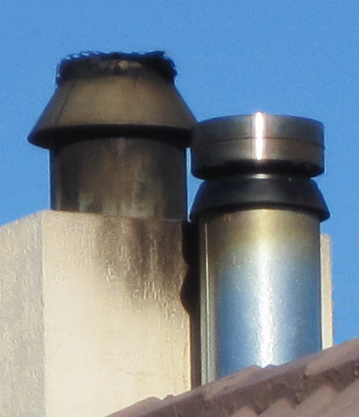

A recently installed compliant flue deposits harmful, filthy soot

over an adjacent chimney

It is not good enough that a wood heater will not burn overnight.

The community is calling on the wood heater industry to employ latest design and technologies that are environmentally healthy and user friendly to heat their homes.

Certification of wood heaters needs to be regulated and only carried out by independent certifiers.

The wood heating industry itself should not be the ones involved with, or carrying out, certification. Cleanairtas has raised genuine concerns and offered advice as to how wood heaters can be made safer and emit less harmful emissions both indoors and outdoors.

The wood heating industry should be made to comply with these conditions, just as home owners have to try and comply with heaters that do not meet their expectations in relation to operation and emissions even though they were bought in good faith and shown to be certified.

**A new set of wood heater certification standards needs to be drawn up by an independent body to protect the population health.**

**Certification needs to be carried out by an independent body; not by the wood heating industry themselves.**

I think we have heard too often that some options are too costly or difficult to implement. This has mainly been cited by the wood heating industry that seems to be controlling the shots.

How can one ever say that health problems caused by wood heaters emissions are too costly or difficult to change? This is not what the people want to hear.

The costs to the community are far in excess.

**There are way too many Standards/Regulations/Codes to do with limiting harmful smoke emissions. The whole process needs to be simplified and brought up-to-date under one standard.**

**Take Tasmania for example. The EPA and Councils have both been seeking legal advice and at the time of writing are still in disagreement over environmental administration matters.**

**Meanwhile, the community is still being forced to suffer toxic smoke inhalation.**

Australian Standard AS/NZS 4013:1999:

This Standard is an Australian and N/Z Standard. At present the NZ emission figure is 1.5g/Kg and Option 9 in the RIS should be adopted to bring it in line with the NZ Standard of 1.5g/Kg. Table E1, Page 3

A 4g/Kg heater is quite capable of producing harmful emissions and so are the many other certified wood heaters installed in Launceston since the successful heater buy-back scheme was introduced some years ago.

This is evidenced by typical indicative air quality readings from the BLANkET real time graphs courtesy of EPA Tasmania. <http://epa.tas.gov.au/epa/real-time-air-quality-data-for-tasmania>

The readings at the fixed real time air monitoring stations across Tasmania (see map below) can be likened to what is happening in one city, one town, or one street, from wood heater smoke.

Depending on the wind direction and the smoke point sources some people will not experience many particulates whilst others might experience high levels over long periods of time.

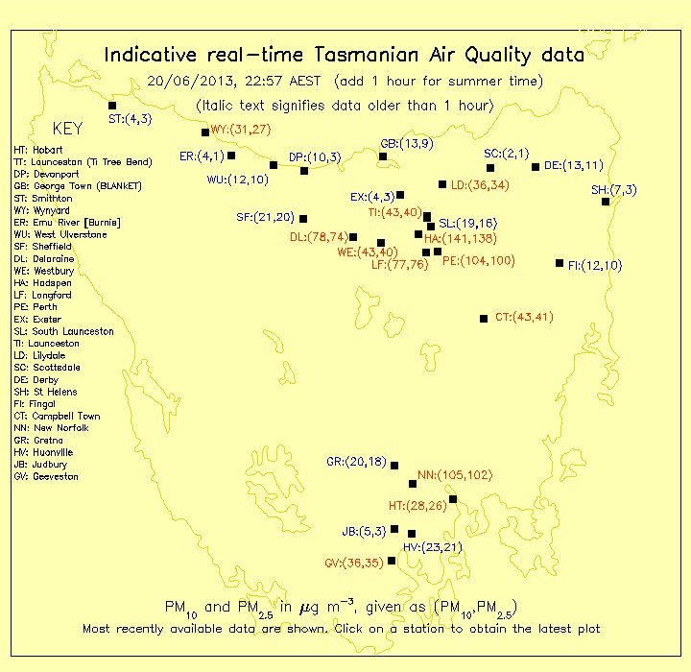

A typical snapshot of wood heating emissions in Tasmania

Figures in red show the PM2.5’s exceed PM25ug/m3.

Maps courtesy of EPA-Air Tasmania.

One resident can live next to a smoking flue and have their health put seriously at risk day and night and yet the averaged 24hour NEPM standard will not show a NEPM exceedance, and the NPI will show we have clean air.

NPI data is not indicative of localised harmful airborne particulates. Of all the states and territories, Tasmania had the highest proportion of its population residing outside of its greater capital city, Hobart (58%) at June 2012

A whole city or town can be subjected to very high levels of toxic wood heater smoke for many hours a day and because the smoke sneaks in under the averaged 24 hour NEPM standard it will not show up as a NEPM exceedance.

Current NPI data and NEPM standards contribute to people’s health demise from wood heater smoke in Tasmania because we have uninformed people jumping up and down saying our air is clean when in places point sources can give very high unacceptable air quality readings for many hours and days on end.

This can best be explained by the following two graphs provided by EPA Tasmania.

Ti Tree Bend air monitoring station is located in Launceston, and

New Norfolk air monitoring station is located in the South of the state.

Additional air monitoring stations in between can measure relatively clean air.

But just imagine how many individual ‘neighbours’ could be experiencing exceptionally high particulate levels to give the averaged readings passing through a fixed air quality station?

Drive around a city with a portable air quality monitor and you will soon see the difference between the PM levels recorded in almost real time from a fixed monitoring station and the portable device. The differences are staggering

Unfortunately, only two or three of these fixed monitoring station levels are being reported for Tasmania in the NPI I believe.

.

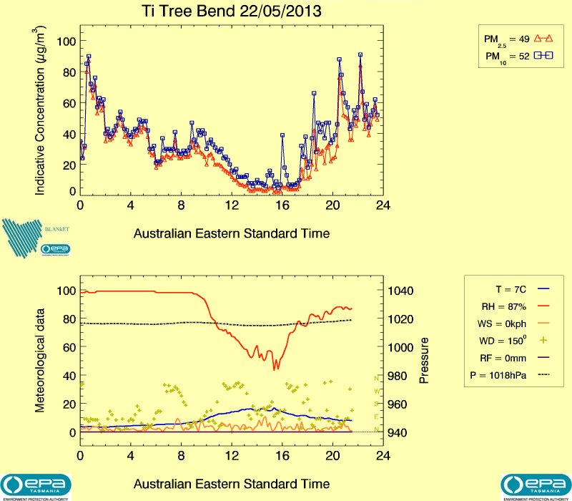

Launceston wood smoke pattern on cold evenings in May.

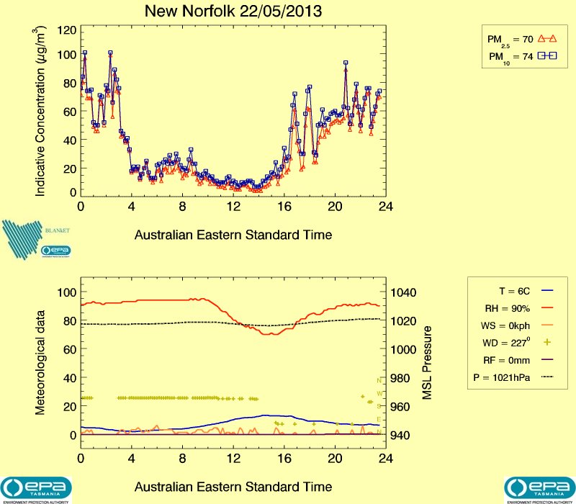

New Norfolk wood smoke pattern on cold evenings in May.

Ambient Air Quality NEPM Standards are worked out on averaged 24hour readings.

For a NEPM exceedance to occur the PM10 standard must be averaged greater than 50 ug/m3 in a 24 hour period starting at midnight.

For a Reporting Standard to be breached the PM2.5 would have to be greater than 25ug/m3 averaged over 24 hours from midnight.

If we look at the plots below we can see the wood heater smoke pattern in N/W Tasmania, and it is spread across two days when it is at its worst. Had it occurred in one 24 hour period commencing at midnight there would most likely have been an exceedance of the NEPM Standard. (“00” equals midnight.)

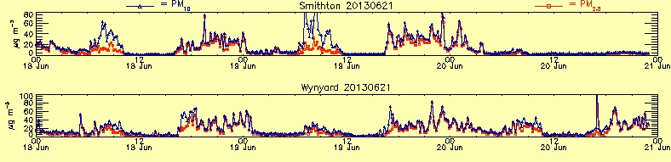

A whole city or town can be subjected to very high levels of toxic wood heater smoke for many hours of the day. Because the smoke sneaks in under the averaged 24 hour NEPM standard it will not show up as a NEPM exceedance.

We desperately require a 1 hour compliance standard to be created additionally for Pm2.5 and PM 10, and the PM2.5 reporting standard needs to be upgraded to a 24 hour averaged compliance standard if we are to make any inroads into being able to breathe clean healthy air.

**So we have a heater why do we want another one?**

We are not convinced we are achieving any real benefit by installing a new certified wood heater.

We all thought we would. The graphs above show us otherwise.

Despite the rather costly purchase and installation price of a new compliant wood heater, our little bit hasn’t helped much at all; not when we also have backyard burns and forestry planned burns dumping may times the particulates into our air sheds. At times we even get particulates coming into our area from planned burns/bushfires on the mainland.

Rather than resorting to using some of the freely offered, well-known, and well-meaning advice around the traps to stop the wood heater flaming out in a few hours and all the emissions and heat going up the flue before it does, and then more accelerants and further smoke from relighting, we decided to have a large electric heat pump installed.

There is no financial incentive where we live to help us produce less toxic emissions from our wood heaters.

We do not have access to town gas, and pellet fires are too expensive to run. We live in the same Tamar valley where one council municipality (Launceston) supports a heater-buy-back scheme, but ours does not.

If solar installations receive a rebate and some wood heater owners qualify for a heater buy-back rebate, why don’t those who swing to a new wood heater or heat pump in the same Tamar valley receive similar? Why not when adjoining council emissions end up in Launceston?

I wrote to the Electricity Reform Project team in Tasmania (Treasury) with regards to the following:

*Households that privately fund the installation of solar equipment receive a benefit back.*

*Households that privately install heat pumps, which in some instances can be up to double or triple the cost of a solar installation, receive no government rebate and yet they can be saving the supply authority anywhere between 300% and 500% in generation and transmission costs depending on the COP of each unit installed.*

*I asked if the team was looking to correct this anomaly and if they can advise me what kind of rebate is proposed to help the home owners who install heat pumps, and when it will be applied.*

The following reply was received:

*Thank you for your email of 18 June 2013 and your query in relation to rebates for home owners who install heat pumps. The Australian Government has provided rebates for the installation of solar and other forms of distributed generation as a means of encouraging householders to decrease their carbon footprint and to ease pressure on the grid by generating their own power from renewable sources.*

*While heat pumps are acknowledged to be a highly efficient form of heating they consume electricity, while photo voltaic (solar) units generate electricity. Hence there is no anomaly that needs to be addressed.*

*Thank you for bringing your concerns to our attention.*

*Kind regards*

*Electricity Reform Project team*

Using the teams own reasoning this raises the following points:

***Decreasing carbon footprint:***

*This is exactly what a household does when it swings over from wood heating or direct electric heating and installs a heat pump.*

*There are no more flue emissions. Direct health benefits for the population just cannot be ignored.*

*Even the new certified wood heaters are capable of emitting 4gms of particulates for every 1Kg of dry wood burnt, and*

*It is estimated that a household burns 10 to 14 tonnes of wood a year in Tasmania.*

*Many of the older wood heaters, or open fireplaces, emit many more times this amount.*

*Then we have reduced power load from the grid by a factor of 1:3 rising up to 1:5, and wood is not being transported or burnt.*

***Easing pressure on the grid:***

*I have raised the fact that a heat pump can be anything from 300% to 500% efficient.*

*For every 1Kw heating or cooling input, it can produce 3Kw to 5Kw output. Each heat pump can be liked to a generator every hour it runs.*

*Compared to direct electric heating, pressure is eased on the grid by 300 to 500%*

***Renewable sources:***

*Tasmania does have renewable sources of electricity.*

*The extra Kws produced by a heat pump are renewable every hour it runs.*

***Photo voltaic (solar) units:***

*Whilst these units can be capable of generating electricity they do not generate electricity all the time.*

*In this situation the household has to source electricity from the grid just the same as a heat pump household does, but at greater amounts, see the following…*

*Heat pump owners are subsidising photo voltaic owners by reducing generation and transmission costs at times of maximum demand on the grid (nights, and cold/overcast days).*

*The grid has to be designed to meet this very costly expected maximum demand and most photo voltaics are not feeding power back into the grid at these critical times.*

**There is little incentive to reduce harmful emissions from wood heaters.**

Applicable information:

Dr Fay Johnston: Evaluation of interventions to reduce air pollution from biomass smoke on mortality in Launceston, Australia: retrospective analysis of daily mortality, 1994-2007. <http://www.ncbi.nlm.nih.gov/pmc/articles/PMC3541469/>

[Video presentations on wood heater smoke by Dr. Fay Johnston, Dr John Innis, and Prof John Todd.](http://epa.tas.gov.au/epa/burn-brighter-this-winter-communications-products)

As you can see much is being done in Tasmania to reduce harmful wood smoke emissions.

It would appear on paper we are making inroads into reducing this smoke, however, real-life situations say we are not at times and a lot of work still needs to be done; especially in relation to wood heater operating and design characteristics.

**And again lately the smoke from wood heaters has been at unhealthy and unacceptable levels in Launceston and other towns in Tasmania.**

Summary:

* Wood heater installers need to be certified and only certified installers should be permitted to install wood heaters.
* Every local government council in Australia should maintain a register of every installed or removed wood heater
* Our Regulators need to listen to our researchers and lung specialists and immediately legislate for the lowest emission and greatest efficiency wood heaters available on the market today. 1.5g/Kg @80% efficiency at least.
* Wood heater smoke is an Australian wide responsibility and to make the swiftest change-over (to new wood heaters, or other low emission forms of heating) that will bring the greatest health benefits the change-over needs to be cost neutral for heater owners.
* People should not have to live in the cold, and in Tasmania we have to heat for about six months of the year. We need to know what heaters will burn overnight and which ones will not.
* The meaningless laboratory type certifications for wood heaters need to be based on real-life operating conditions. Burn times need to be stated and so do the number and size of particulates that are emitted from the heater flue, and from the heater itself in an enclosed space.
* Wood heaters and installations need to be redesigned to allow for the pre mentioned features to improve combustion and quenching that will reduce harmful emissions inside and outside the home.
* Our wood heater standards need to be simplified to allow for consistent state administration across the country. Legislation needs to be put in place to make sure states are complying with the standards.
* A new PM2.5 and PM10 one hour compliance standard needs to be brought in, and the PM2.5, 24 hour average advisory standard needs to be changed to a compliance standard. This would give a truer picture of unhealthy emissions.
* Our wood heater standards need to be set at a level to reflect current and future emission levels in relation to health outcomes for susceptible groups.
* Previous changes to our heater certification standards are not showing the benefits imagined. See the previous graphs for wood heater emissions today in Tasmania.
* Wood heater certification must be undertaken by an independent certification body that is competent to regulate and administer new certification standards to protect users of wood heaters and the community.
* Wood heater certification must not be left to the wood heater industry itself or we will still be dealing with people forced to live in the cold and excessive emissions such as those being experienced in Tasmania after the previous legislative changes.

Acknowledgements:

Thank you to those who have been quoted in this submission and to EPA-Air Tasmania.

Thank you to unknown sources for their photos and graphics.

Who is Clive Stott.

Born in Tasmania.

Worked in avionics in Victoria and on high voltage systems in NSW.

Worked for the Tasmanian Health Dept. for 15 years in hospital engineering and biomedical engineering.

Additionally provided oxygen therapy equipment support to respiratory patients in their homes for CIG/BOC Gases.

In 2008 suffered clots,DVT and PE’s from environmental wood smoke in Tas.

**Cleanairtas exists to help protect the public from harmful wood burning smoke.**

**This is achieved through, education, community involvement, and activism.**