The bad air quality could be affecting your pets
by Tristan Balagtas
http://kimatv.com/news/local/the-bad-air-quality-could-be-affecting-your-pets

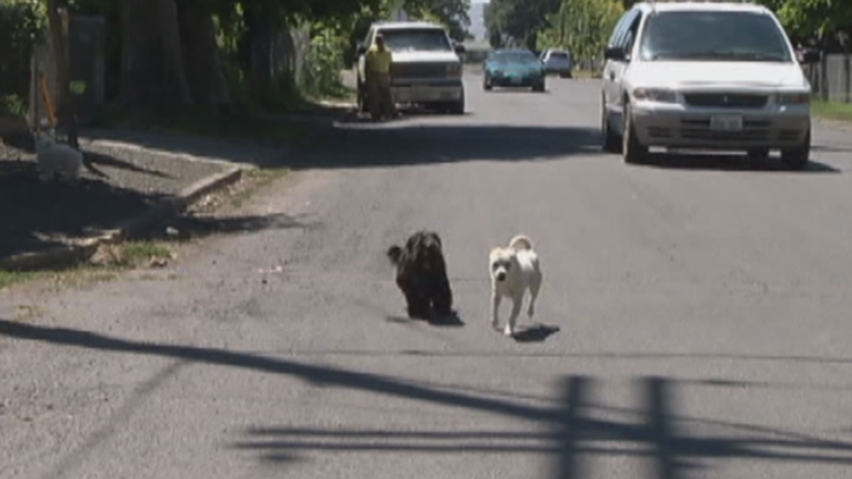
pet air quality.PNG
Yakima, Wash.-- With the ongoing wildfires, Yakima's air quality is still at unhealthy levels. What does this mean for your pets?
Jennifer Fitzpatrick is the Medical Director of the Yakima Humane Society, and she said bad air quality is not only an irritant, it can cause serious respiratory issues, including for your pets.
“In our pets, it causes dry sinuses, just like us. They can end up with nose bleeds, lung irritations; they can get a cough. Pets also can have allergies and asthma as well, and this can be a big exacerbating factor for that,” said Fitzpatrick.
Fitzpatrick recommended pet owners keep their pets indoors where the air is cleaner and usually filtered by your a-c system. Short trips outside and limiting outdoor activity is especially important for pets who are young, old, or have respiratory diseases.
For more information, you can go to yakimahumane.org.
-11/9/2017=

