January 4 2020 - 11:40AM

Alert issued as smoke blankets Tasmania
Originally published at: https://www.examiner.com.au/story/6565979/alert-issued-as-smoke-blankets-tasmania/?cs=12

Rob Inglis

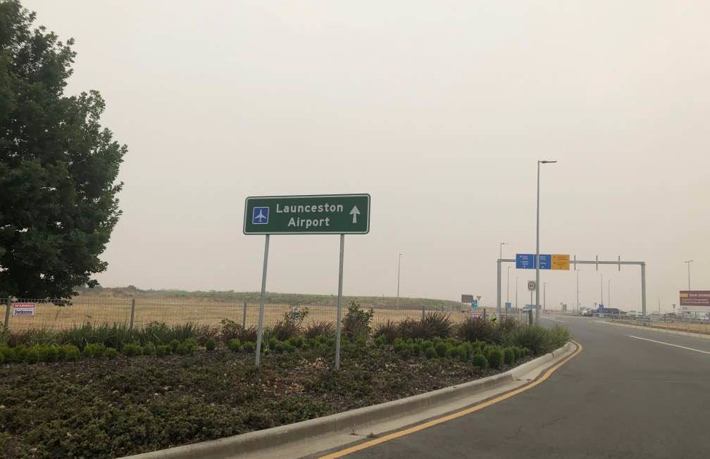
A haze settles over Launceston Airport on Saturday morning. Picture: Paul Scambler
Smoke from the Victorian bushfires has blanketed Tasmania this morning, prompting the Tasmania Fire Service to issue a smoke alert for the entire state.
A north-northeasterly has wafted smoke across Bass Strait into Tasmania, with the North and Central Tasmania being hit particularly hard.
Air quality index readings show that much of Northern Tasmania currently has very unhealthy air quality, with some areas reaching hazardous levels.
Public Health Services has urged Tasmanians to stay indoors when it's very smoky outside and stressed that people with asthma or other health conditions needed to follow their health plan and work to reduce the amount of smoke they breathe.
There are currently four fires at Fingal at watch and act level and two listed at advice level.
In the South and South-West of Tasmania, fires continue to burn in places including Elderslie, Broadmarsh, Pelham and Pearce Basin.
Bureau of Meteorology duty forecaster Anna Forrest said the smoke had drifted onto the North Coast, down the East Coast and into the South-East of Tasmania.
"It's pretty widespread," she said. "It's not confined to just the North of the state."
However, Ms Forrest said a westerly trough and a cold front forecast for later this afternoon would likely push the smoke in a south-westerly direction.
"That will just send it all back up the same track that it came down overnight," she said.
SEE HOW THE SMOKE FROM THE VICTORIAN BUSHFIRES BEHAVED ONCE IT ARRIVED IN TASMANIA IN THIS SATELLITE IMAGE LOOP FROM BOM (7AM TO 10AM)
As at 9am this morning, St Helens had a reading of 328, which is considered hazardous, while Scottsdale had a reading of 376.
Other parts of the North-East are struggling, with a very unhealthy air quality reading of 252 at Lilydale and 297 at Derby.
Meanwhile, South Launceston had an unhealthy reading of 188, Longford had a very unhealthy reading of 218 and Westbury had a very unhealthy reading of 221.
Director of Public Health Mark Veitch said the air quality was worse in the northern and central regions of Tasmania but added that the south was also affected.
"Very poor air quality poses a health risk, particularly to vulnerable people," Dr Veitch said.
"Those most at risk are people aged over 65 years, babies and young children, pregnant women, and those with heart or lung conditions, including asthma.
"Even healthy people can experience short-term health effects in very poor air quality conditions.
Air quality in Launceston today is “poor” and may cause breathing discomfort. This smoke will probably linger all weekend #politashttps://t.co/k0nXpzi47Spic.twitter.com/KB9P6RMsPj
— Adam Holmes (@AdamHolmes010) January 3, 2020
"A weather change forecast for the late morning and afternoon may shift the smoke from Victorian fires that is currently affecting Tasmania."
Dr Veitch advised Tasmanians to set air conditioners to recirculate air, avoid exercising outdoors and, if need be, to go somewhere less smoky such as a friend's place.
If you become unwell, seek medical assistance.
Police have also warned motorists and other road-users to drive to the conditions, noting that the prevalence of smoke was reducing visibility.
Inspector Brian Edmonds advised drivers across Tasmania to slow down in areas of decreased visibility and to keep their headlights on.
On Saturday morning, Bridport Triathlon had to be cancelled due to poor air quality. On Facebook, the Launceston Triathlon Club said conditions were not safe to compete in.
A total fire ban was put in place for 24 hours as at 2am on Saturday.
For more information on health issues that can arise from poor air quality, visit www.health.tas.gov.au/publichealth/air/bushfire_smoke.
----------------------------------------------------
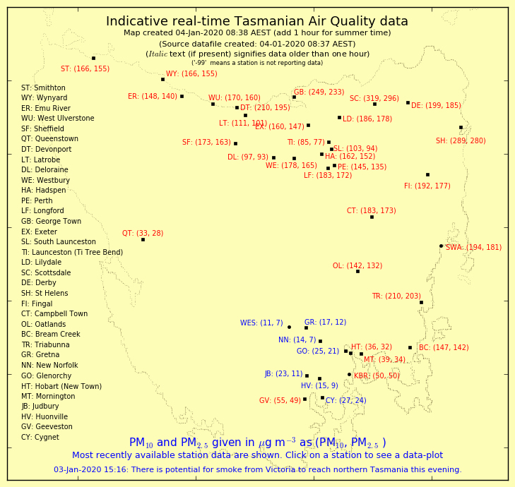
EPA Tasmania Air Quality Division – Real–time PM10 &PM2.5 A/Q readings at 08.37 hrs

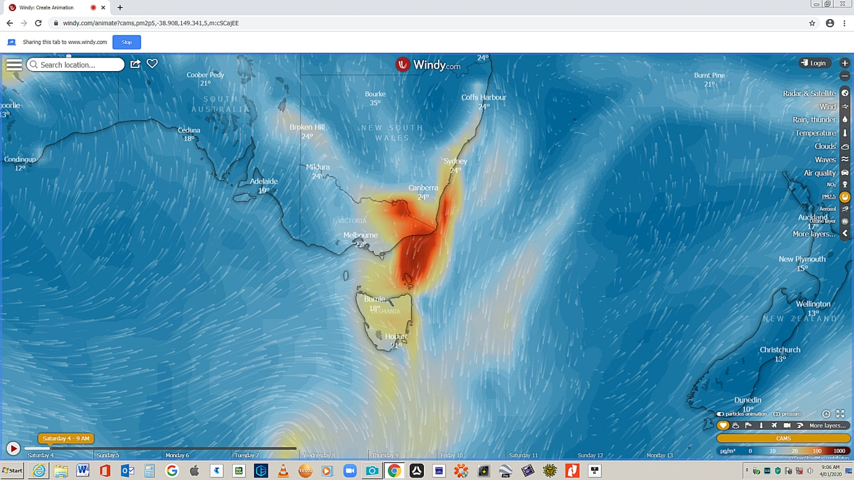
Windy.com PM2.5 particulates coming into Tasmania at 08.52 AEST

