17/2/2022 - Tasmania is burning again. We should have brought in a very large water bomber to put this fire out to save the environment and stop the smoke, or are they planning to play with fire like at Lebrina?
ABC
Fears for ancient Huon pines as fire sweeps through Tasmanian wilderness
By April McLennan
Posted 3h ago3 hours ago
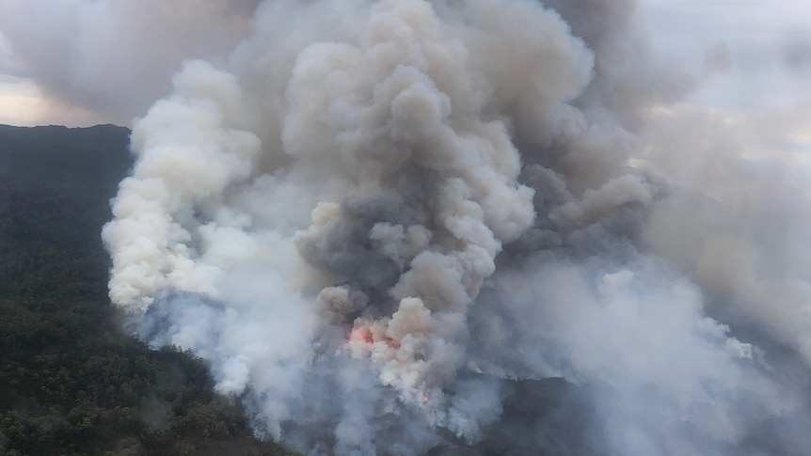
The fire in Tasmania's remote south-west wilderness is only kilometres from a significant stand of ancient Huon pines. (Supplied: Tasmania Fire Service )
Help keep family & friends informed by sharing this article
abc.net.au/news/fears-for-ancient-huon-pines-as-fire-sweeps-tasmanian-wilderness/100840254
COPY LINKSHARE
There are concerns a bushfire burning in Tasmania's remote south-west wilderness area could threaten an "irreplaceable global treasure".

Key points:
- A fire in the Franklin-Gordon Wild Rivers National Park started on Tuesday and has already burned through 300 hectares
- The fire is only a short distance from a globally significant stand of ancient Huon pines
- Weather conditions are expected to improve over the next few days but deteriorate next week
The fire, —at Olegas Bluff, inside the Franklin-Gordon Wild Rivers National Park — started on Tuesday and has burned more than 300 hectares of bushland.
That area is famous for its ancient Huon pine trees and rugged landscape, ranging from button grass moorlands to eucalypt and rain forests.
In an effort to contain the blaze, Tasmania's Parks and Wildlife Service is using four light planes to water-bomb the western boundary and has sent in a remote area fire-fighting team.
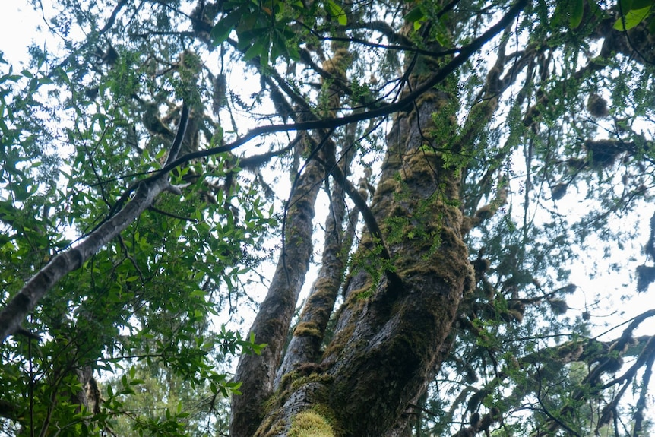
Huon pine is found only in Tasmania and can grow for up to 3,000 years. (Supplied: Dan Broun )
"The remote crews will be prioritising their fire-fighting attacks around some sensitive natural and cultural values on the fire ground," Parks and Wildlife incident controller Alex Bradley said.
"They will get a remote kit airlifted into them, which contains fire-fighting gear — from water bladders, pumps, hoses and a range of other gear — needed to set up mobile water supplies to pump out of existing rivers."
Journalist and environmentalist Andrew Darby said he was concerned about how close the fire was burning to the Truchanas Huon Pine Reserve, which includes a stand of ancient pines.
Huon pine is found only in Tasmania and can grow for up to 3,000 years.
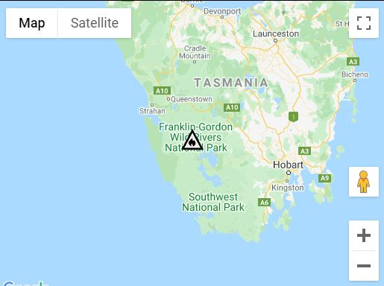
The fire is burning near Olegas Bluff in the Wilderness World Heritage Area. (Supplied: Tasmania Fire Service )
"The Truchanas Huon Pine Reserve is an irreplaceable global treasure," Mr Darby said.
"You can just imagine that something as precious as this must be protected, it absolutely must be protected.
"It cannot be allowed to burn. You cannot allow for something as treasured as this to burn."
The Truchanas reserve is named after Olegas Truchanas, a pioneering photographer whose images of the Tasmanian wilderness became world famous.
He was closely associated with the fight to save Lake Pedder from being flooded by the Hydro-Electric Commission and battled to save the Huon pine forest that now bears his name.
Mr Bradley said the fire was only a "couple of kilometres" from the reserve and the incident management team, set up at Strathgordon, was looking at the best way to protect it.
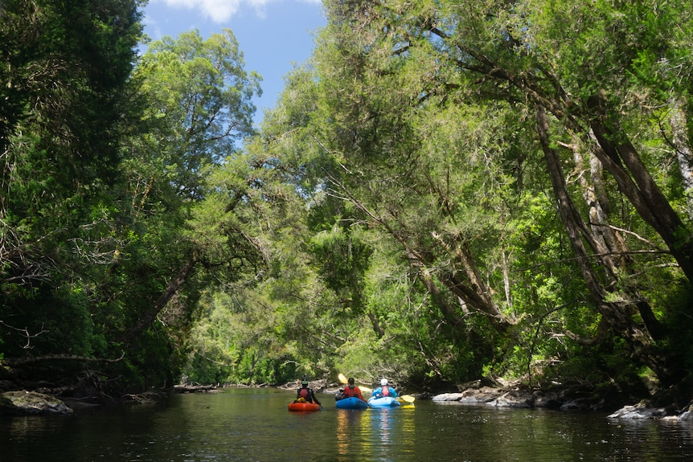
A remote area fire-fighting team will use river water to help quell the flames. (Supplied: Michael O'Connor)
"We've got options, such as different types of aircraft. We've got ground crews that are hoping to suppress the fire long before it gets there," Mr Bradley said.
"If it burnt through [the Truchanas reserve] under the conditions that we're seeing today on the fire grounds, low to moderate conditions, it probably wouldn't do too much harm.
"But, if it burnt through on a hot and windy day, which we are expecting from next Wednesday, it would be a different story."
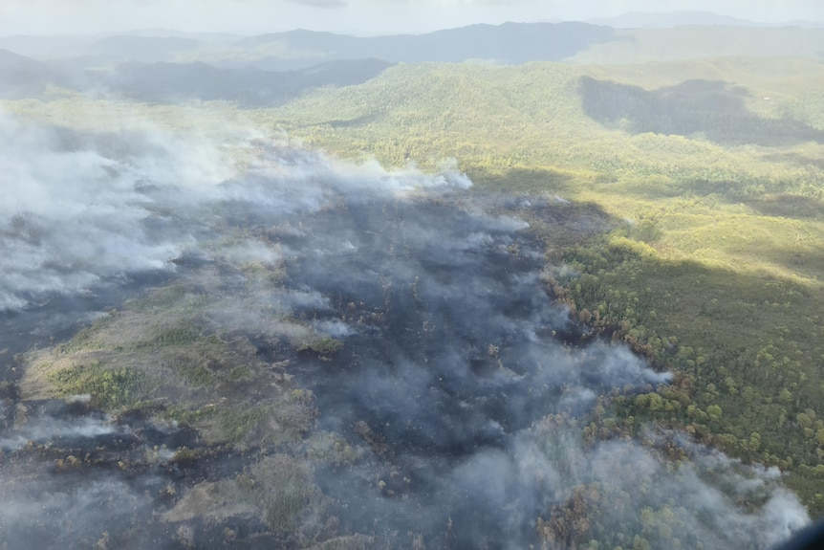
The fire has burned through more than 300 hectares over two days and conditions are expected to worsen next week. (Supplied: Tasmania Fire Service )
Bureau of Meteorology duty forecaster Anna Forest said winds in the area were blowing around 40 kilometres per hour and it was about 18 degrees Celsius.
"At the moment, it's dry and windy, which is not the best for a fire," she said.
Winds are likely to ease on Friday and cooler conditions are on the way.
"It's going to depend a lot on the terrain, exactly which side of a hill you're on, as to exactly the temperature you're going to get," Ms Forest said.
"There could be a few showers through tonight, into tomorrow morning, but it's not big totals, unfortunately.
"It could be just enough to dampen things down a bit, but not enough to dampen any flames that are around."
Several walking routes within the national park are closed because of the fire, including access to the Hamilton Range and Truchanas Pine Forest Reserve via the Gordon Dam, the Prince of Wales Range, and Pearce Basin to the Denison River.
Visitors to the area are advised there will be increased road traffic and the presence of aircraft around the village at Strathgordon.
https://www.abc.net.au/news/2022-02-17/fears-for-ancient-huon-pines-as-fire-sweeps-tasmanian-wilderness/100840254

https://www.nafc.org.au/fleet/#AircraftTypes

https://www.fire.tas.gov.au/a/90380

