31/01/2019 - Smokewatch

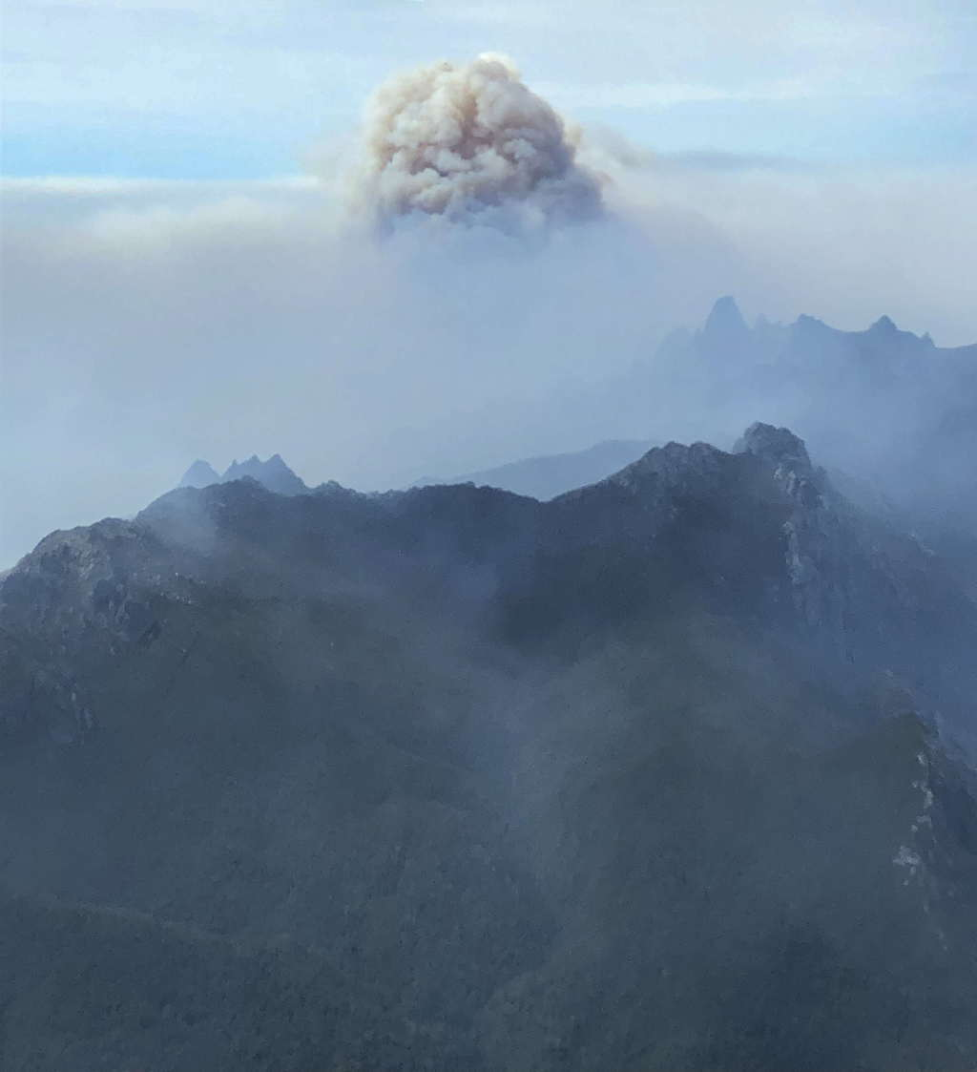

<https://tasmaniantimes.com/2019/01/impending-tragedy-at-the-tasmanian-wilderness-world-heritage-area/>



Sentinel Hotspots – 31.1.19…1300UTC

[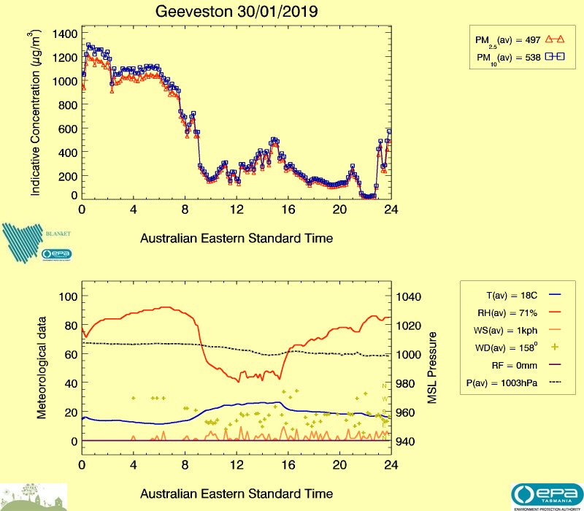](https://epa.tas.gov.au/air/live/GV_yesterday.jpg)

30/1/2019- Geeveston air quality. Data courtesy of EPA air section