25.01.2019 – Smoke hangs in and over the Tamar valley.

Launceston is down there somewhere.

There is no escape people have to breathe this cancer causing smoke.



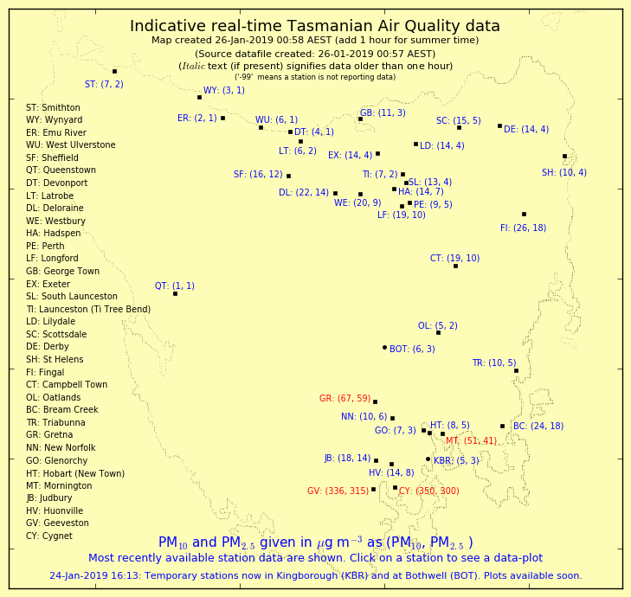

Real-time air quality readings from EPA Tasmania.

[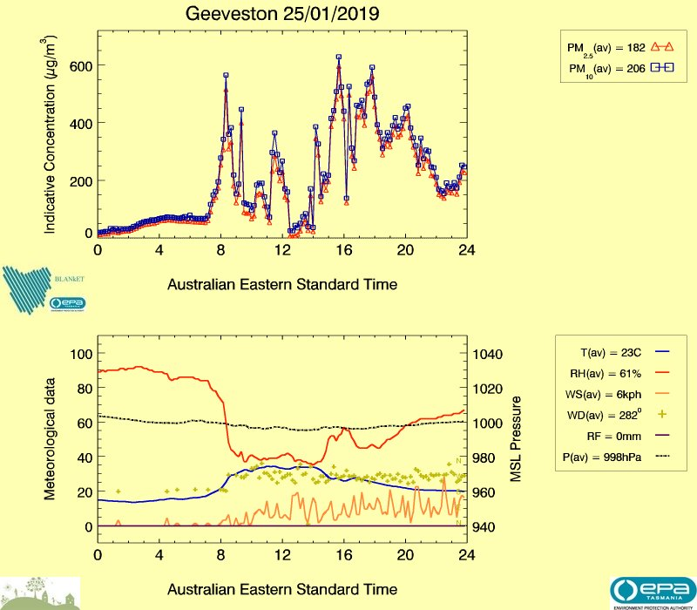](https://epa.tas.gov.au/air/live/GV_yesterday.jpg)

EPA Air Quality reading for Geeveston in the South of the state.

Less than 25ug/m3 is considered clean air.



Tasmanian Fire Service Incidents map for day ending 25.01.19

Red - Emergency warning

Yellow – Watch and Act

Blue – Advice

White – No Alert Level

[Bushfires in Tasmania](https://www.abc.net.au/news/2019-01-26/bushfire-danger-not-over-as-tasmania-heads-into-australia-day/10752090) – ABC report 26.01.19

<https://tasmaniantimes.com/2019/01/the-heart-of-tasmania-is-on-fire/>